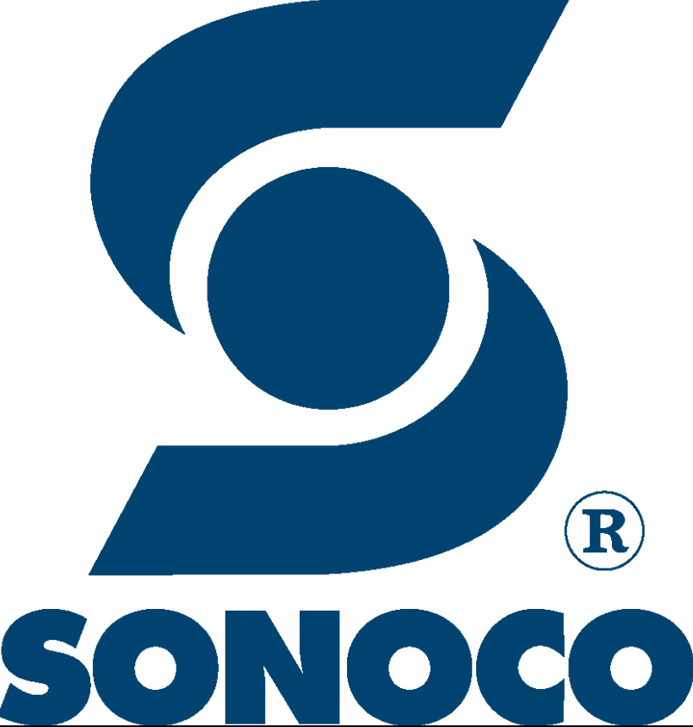
COVID-19 Response to Incentive Pay Inquiries
Situational Overview for Leaders Only:
Incentive pay for employees working on-site at manufacturing and related facilities has been a key news story that has gained prominence over the last few weeks as the COVID-19 pandemic has escalated. The recent coverage, frequently focused on companies in food and grocery, represent what we believe to be a small number of organizations who are adopting incentive bonuses and premium increases to employees. Sonoco has been monitoring these developments through partnership with industry leading market research firms who specialize in compensation data and trends.

General Talking Points: for Employee Questions regarding COVID-19 incentive compensation:
- As always, Sonoco’s upmost priority is to create a working environment where Sonoco employees feel cared for and safe. Even in these challenging and uncertain times, we remain committed to that end.
- Sonoco continues to monitor market developments and industry trends related to compensation best practices. Our goal is to ensure that employees are compensated competitively for the work they do.
- Many of you will have heard about other companies offering attendance bonuses or hourly wage incentives to ensure people come to work. Sonoco is unique in that most of our businesses have been defined as “essential” under state and local orders because customers depend on our products to get food and medical supplies into the hands of people across our global communities. Because of this “essential” status, we do not have the option of discontinuing our operations.
- At Sonoco, we have and continue to take all possible steps and precautions to ensure that our employees are protected as they work in these “Essential” business operations.
- For essential employees working onsite, we have instituted deeper and more frequent cleanings, Employee Health Screens, and other forms of employee recognition at the individual plant level to assure safety and encourage our employees. These steps eliminate the hazards that other industries who work in public spaces cannot control.
- Sonoco will continue to pay competitively at all levels of the organization. At this time, we do not believe that broad incentive pay schemes will improve upon our efforts to ensure a safe working environment for our team.
- We have, however, offered paid time for employees required to quarantine, a faster process to Short Term Disability for ill or high-risk employees, and unpaid time with no performance discipline to manage child and elder care issues without a government mandate. We have made these changes because we believe it is the right thing for our people.
- Our company has been standing strong for more than 120 years, and we have faced a number of obstacles during that time. We’ll face this one as we have all others, with teamwork, determination and as a family.

