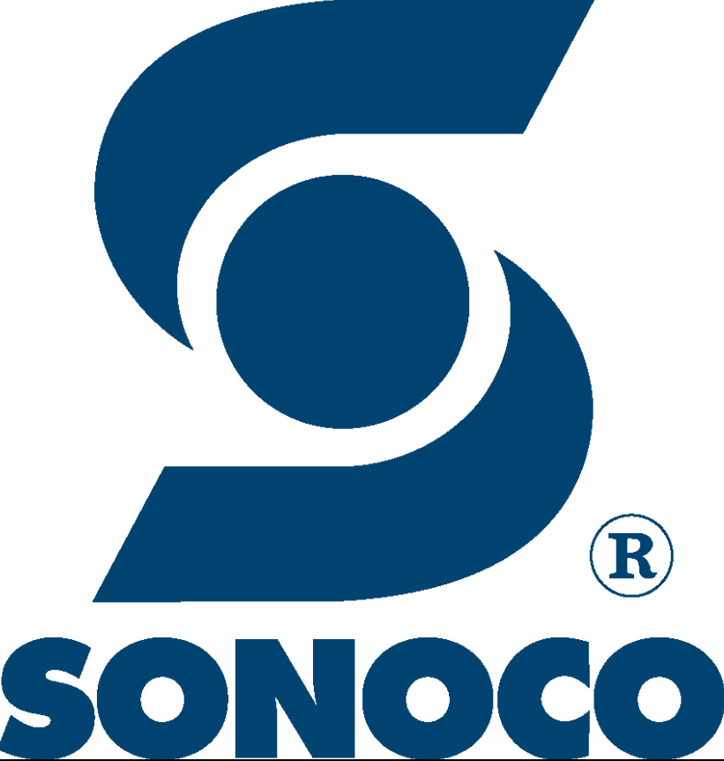
COVID-19 Local Response Outline For Leaders
Scope:
- This applies to all Sonoco operations.
- Governmental regulations will supersede this policy, unless Sonoco’s policy is more stringent.
- All guidelines follow CDC and WHO recommendations.
Immediate Action:
- If the employee is at work they should immediately be sent home and told to contact their healthcare provider.
- If the employee reports sick from home tell them to remain at home and contact with their healthcare provider. If the employee had worked the previous day ascertain where they had worked and whom they had worked in close contact with.
Coworker Notification:
- Notify employees who may have been in close contact with the sick employee and instruct them to self-monitor for illness and fever. Do not disclose the sick person’s name or any medical status.
Cleaning & Disinfecting:
- If an employee reports illness during work hours:
  - Isolate the work area and wait as long as practically possible before cleaning.
  - Use standard cleaning materials to thoroughly clean all hard surfaces that may have been touched by the employee.
  - Ensure all breakrooms, restrooms and other areas the employee may have been are also cleaned.
  - Standard PPE for cleaning activities should be worn including gloves and eye protection. Product safety data sheets can be referred to for guidance on specific products.
Communication:
- Notify the division safety leader and human resources representative of the issue.
- Verbally communicate with employee’s onsite of the measures being taken to protect them.
  - Dedicated resource for the sites COVID-19 plan.
  - Increased cleaning frequency with focus on high-touch surfaces.
  - Social-distancing requirements established.
  - Response plan for possible workplace exposures.
- Refer any and all press inquiries or social media issues to Corporate Communications.

