3.1 Screening and quarantine
Contents:
3.1.1 What does screening mean? 2
3.1.2 The difference between “passive” and “active” screening 2
3.1.3 The possible benefits and drawbacks of screening 3
3.1.4 When to use “active” screening; when to use “passive” screening 4
Table 3.1 Guide to when “active” or “passive” screening may be implemented 5
3.1.5 “Passive” screening 6
3.1.6 “Active” screening 6
3.1.7 Temperature screening 8
3.1.8 Using thermometers or thermal imaging cameras 8
3.1.9 What is quarantine? 9
3.1.10 Return to work 9

Other supporting material for Section 3: Screening and quarantine
3.2.1 PROCEDURE Passive POE Screening
3.2.2 PROCEDURE Active Screening
3.4.1P POSTER A4 (SAMPLE) Passive Screening Alert
3.4.2P POSTER L (SAMPLE) Passive Screening Alert
3.4.3P POSTER A4 (SAMPLE) Passive Screening Alert
3.4.4P POSTER A3 (SAMPLE) Passive Screening Alert
3.4.5A POSTER L (SAMPLE) Active Screening Alert
3.4.6A POSTER A4 (SAMPLE) Active Screening Alert
3.4.7A POSTER A3 (SAMPLE) Active Screening Alert
3.5.1 TOOL Staff Screening Questionnaire

Companies who wish to prevent/reduce transmission of flu within the workplace may wish to implement screening measures. These aim to prevent infected people (including employees, vendors, contractors, and visitors) from entering the workplace. This may reduce the number of employees becoming infected, especially the number of those infected simultaneously, and thus help maintain business continuity. Screening measures will NOT identify all people who are sick or infectious, and they will not completely prevent employees from being exposed to influenza in the workplace.
In some locations, public health authorities may mandate that screening is carried out. Organizations may then be required to rapidly implement procedures according to local guidance.


3.1.1 What does screening mean?
In pandemic influenza planning, screening refers to:
- Identifying the groups of people that may enter your workplace (including employees, vendors, contractors, and/or other visitors)
- Establishing systems to identify people who are infected, or who may be infected, BEFORE they enter the workplace**
- Preventing these identified people (cases and suspected cases) from entering your facility
- Referring these identified people for appropriate medical evaluation and/or treatment
** in some circumstances, it is impractical to screen employees before they enter the workplace. If so, screening may occur soon after they enter.

3.1.2 The difference between “passive” and “active” screening
There are two main types of screening, “active” and “passive”.
Active screening: people are checked by appointed staff member/s before they enter the premises. These “screeners” must be trained in the screening procedure.
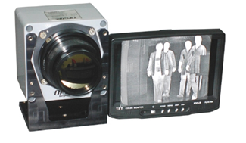
Examples:
- Checking entry questionnaire responses prior to allowing people to enter the workplace (questionnaires ask about symptoms or risk factors, such as fever or travel)
- Checking people’s temperatures, and only allowing people with normal body temperatures to enter the workplace

“Passive” screening: people self- screen using directives and questionnaires as requested, without being screened by appointed staff members.
Examples:
- Directive not to attend work if you are sick
- Poster put at workplace entrance advising people not to enter if they are sick, or family members are sick
- Directive not to enter the workplace after travel to “affected areas” unless clearance obtained from management

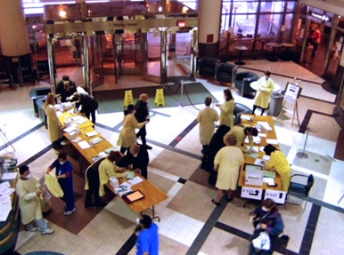
3.1.3 The possible benefits and drawbacks of screening
The benefits of introducing screening programs can include:
- Possible prevention/reduction/delay of introducing the virus into the facility; may reduce transmission of the virus in the workplace
- Improving staff awareness of the situation
- Improving staff compliance and vigilance regarding company policies (corporate or local)
- Demonstrating to staff that the organization cares for their well-being and is doing its best to protect their health
- In certain countries, early identification of possible cases may reduce the likelihood of mandatory quarantine of possible contacts / facility closure by health authorities
- Organization can rapidly comply if local health authorities require screening procedures
The drawbacks of introducing a screening program can include:
- Disruption to business
- Expense
- False sense of protection
Screening will not identify every person who is infectious (able to pass the virus on to others). Some people entering may evade the screening. Others may be carrying the virus but do not have the symptoms or risk factors being screened for (such as fever, travel or exposure history). People can be infectious before they have a fever, and thus they seem well. In these cases, the infected person will enter the workplace without being identified as a risk via screening measures.
There is a lack of clear “scientific evidence” that screening is comprehensively beneficial in reducing the spread of infectious diseases. The few analyses available have looked at the use of screening for fever at international borders and in hospitals. Results showed only very few people were detected with a fever compared to very high numbers of people being screened. There are no studies which have looked at the benefit/lack of benefit of screening programs in the workplace. Nevertheless, screening people for fever during an epidemic/pandemic is often performed at international borders, healthcare facilities and other public places by national health authorities. Regulations sometimes mandate that organizations implement screening in their own facilities.


Organizations are advised to complete a cost/benefit analysis of screening procedures when developing company-specific pandemic preparedness plans. Some methods of screening, especially active screening measures, are highly costly and disruptive. Other methods are relatively simple and inexpensive to implement.

3.1.4 When to use “active” screening; when to use “passive” screening
The decision whether to implement any form of screening, and whether it should be “active” or “passive”, is guided by:
- The severity of the virus
- The impact that the virus is having on your local community
- Your company’s risk tolerance
- Local public health directives
- Your ability to implement and manage the process and the outcome

Table 3.1 is a guide to when “active” or “passive” screening might be implemented. Where there is a choice, more risk-averse companies may choose “active” over “passive” Methods. The Table refers to the “Trigger Points Definitions” of the Phase 5 and 6 Action Table.

Table 3.1 Guide to when “active” or “passive” screening may be implemented
No cases reported in country |  |  | Cases reported in country

No cases in country |  |  | No local cases | Limited numbers of local cases |  |  | Significant or rapidly increasing numbers of local cases |  | No new cases in community
No cases in country |  |  | Cases in country  No cases in local community | Limited transmission in community  Gradual increase in number of local cases  May or may not be employee cases |  |  | Widespread transmission in community and/or  Rapid increase in numbers of local cases  May or may not be employee cases  Considered an AFFECTED community |  | No (or few) new community cases  Existing cases resolving
Severity | Types of Screening
Mild / moderate | Nil | Nil |  |  | Passive | Active or Passive |  | Passive
Severe | Nil | Nil |  |  | Active or Passive | Active |  | Active or Passive

3.1.5 “Passive” screening
The purpose of passive screening is to raise awareness of the illness. It works by allowing people’s common sense and sense of duty to guide them to making sensible decisions. However, unlike in active screening, these self-made decisions are not checked. In passive screening, the company relies on individuals to be honest and responsible.
Passive screening can be implemented in a variety of ways. Different companies will find that some methods are more suitable to their needs than others.

Examples of passive screening:
Informing employees of a new policy which asks them to stay out of work, and instead quarantine at home for [XX] days, if they are sick, if anyone in their home is sick, if they had contact with anyone who is sick, or if they have traveled to an “affected area”.
Encouraging sick employees to go home, seek medical advice, and stay away from the workplace until they have recovered.
The methods below are all ways to carry out passive screening:
- Sending an email to all staff

- Displaying posters at entry points
- Displaying posters around the workplace

3.1.6 “Active” screening
In active screening, appointed and appropriately-trained person checks people entering the workplace for illness, or for the possibility they are incubating illness. Active screening can be disruptive, and would be used when the risk of not identifying a sick person prior to entry outweighs the disruption.
Active screening can be as simple as calling employees before they leave for work to check that they are not sick. However, active screening may also be more involved. When a person is required to undergo a review before entering the building, it is known as “Point of Entry (POE) Screening”.

Active POE screening: Where, Who, How, and What
Where should the screening be performed?
Identify the number of entrances at your workplace, including those that come direct from parking facilities. Decide which entrance(s) will be assigned door screening procedures. Ideally, to reduce cost and increase effectiveness, all entrances but one should be closed off. The screening process should take place close to the selected entrance.
Sometimes it is not practical or possible to set up active screening at the main entrance of the building. Those who are planning the screening procedures should identify practical alternatives. For example, it may be easier and less disruptive to have screeners walk through the office shortly after employees arrive. In this approach, employees should limit their movements until they are screened after arrival. People who arrive after screening has been performed should be instructed to go to a designated place to be screened before they go about their work. This method is less robust than door screening and allows more opportunities for influenza to spread in the workplace. That may be an acceptable risk, especially if the virus is mild.
Who should perform screening?
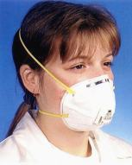
Specific personnel should be appointed and trained to perform screening. Ensure you appoint sufficient staff so that the screening procedures do not create congestion at the entrance to your facility, and to allow for absences or time off among the screening staff.
How do we protect the employees doing the screening?
Personnel performing screening should be provided with appropriate training and Personal Protective Equipment (PPE) to minimize their risk of becoming infected. If there is a high risk of transmission to screening staff, and antiviral drugs are available, you may want to provide them to screeners for prophylactic use.
What should screeners do?
Point of Entry (POE) screeners must, in advance, know the procedure for handling people who are sick and others who will not be allowed to enter the premises. They also need to know which room has been designated for isolation purposes on-site.
POE screeners should carry out the following procedures:
- Visually scan for signs of sickness. Some people may be coughing and sneezing, or appear feverish and pale. Be cautious during interactions to prevent infection. Ask them to leave the premises and seek medical attention.
- Give all visitors / employees the screening questionnaire or verbally ask the questions and check their responses. People who answer “yes” are at higher risk of having influenza. Ask them to leave the premises and seek medical attention.
- If a person answers “no” to all screening questions, take their temperature.
- If no fever is detected, allow the person to enter the workplace.
If someone has a temperature of 38.0ºC (100.4ºF) or greater:
- Arrange for the person to leave the premises and attend a medical evaluation (as long as he or she is well enough to leave immediately and independently). Give the person a mask to put on, and direct them to go home. Advise them to telephone the medical facility for advice on what to do and where to go. Calling in advance allows the medical staff to take infection precautions.
- If the person cannot leave independently, direct them to your organization’s pre-identified areas which will be used for isolation. Inform the pandemic team manager.

3.1.7 Temperature screening
A fever over 38°C (100.4°F) is often a symptom of influenza infection. People who have a fever caused by the flu are infectious (able to pass the virus on to others). Consequently, in the event of a flu outbreak or pandemic, it may very useful to determine someone’s body temperature when they enter your workplace. Anyone with a fever is assumed to be infectious and should be instructed to leave to reduce the risk of spreading illness to others.
The temperature of employees and visitors can be monitored by:
- checking the temperature of each individual by using a thermometer
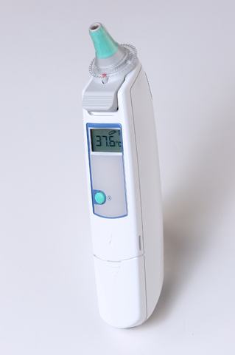
- using infrared thermal imaging cameras for mass blind screening as people enter

3.1.8 Using thermometers or thermal imaging cameras
Your company must decide which method of screening best suits its circumstances. Equipment should be stockpiled in advance and properly maintained. Pre-train screeners on how to use it.
- It is important to choose thermometers that have been approved by relevant authorities, such as the Therapeutic Goods Administration (Australia), the Food and Drug Administration (USA) or CE certification (Europe).
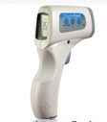
- While glass mercury thermometers are widely regarded as the most accurate tools to measure body temperature, they can take several minutes to obtain a result. Oral and underarm use is invasive and generally inappropriate for screening a large number of people.
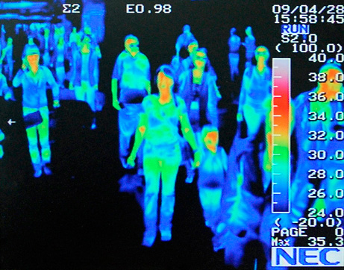
- Digital ear thermometers and temporal (forehead) thermometers are minimally invasive and provide results in 1-2 seconds. They can be used with disposable covers for safely screening large numbers of people. However, they still involve physical contact between the screener and the person entering the workplace.
- Non-contact thermometers are minimally invasive and are easy to use. However, they can only be used under certain environmental
conditions. Accuracy can be a problem.
- It may be appropriate for companies who have large numbers of people entering their premises to consider using thermal imaging cameras as a first line means of scanning for fever. The infrared camera captures an image of each person, then sends the image to a software package. It sounds an alarm if an individual’s body temperature registers above a predetermined threshold (usually 38ºC). This equipment is costly. Anyone detected with an elevated body temperature via thermal scan should have their temperature rechecked with an accurate thermometer.

What is quarantine?
There is some confusion between the words quarantine and isolation, which are sometimes used interchangeably. Both words mean that someone who is infected (or who might be infected) is physically kept away from other people. This separation helps reduce the risk that the person will spread sickness. In quarantine situations, it is not yet known whether the person being kept away from others is infected. People who do not have symptoms are sometimes quarantined if they have a history of travel, for example, or have recently been in contact with someone who is ill. Technically, the term isolation is used when people who display symptoms are kept apart from others.
Quarantine may be applied by public health authorities, and can be mandatory or voluntary. The recommended length of quarantine is equal to the disease’s incubation period. The incubation period is the time between someone being exposed to flu virus and the time they actually start having symptoms. People can be infectious before showing symptoms, and it may be appropriate to keep them away from others during this time – especially if the virus is severe. Some people who are exposed to flu may never be infectious or fall ill. Hence many people may be quarantined unnecessarily.
The incubation period for pandemic influenza will not be known with certainty until the pandemic virus has been studied. Based on seasonal flu, it may be short (1-2 days) or it could be longer (up to 7 days). It is anticipated that health authorities will recommend quarantine periods once the incubation period is determined.


Return to work
In general, people with flu symptoms (fever, cough, runny nose, sneezing etc.) are infectious and should not come to work. Ideally, they should stay out of work the entire time they are infectious. Health authorities may give guidance on how long flu sufferers are infectious (e.g. 7 days after symptoms start, or for 24 hours after symptoms go away, whichever is longer). In some instances, authorities may reduce this period for people who are on antiviral treatment (e.g. after 3 days of treatment with antiviral medication). Some companies have considered asking who have been on sick leave obtain medical clearance to return to work. However, in a pandemic situation, this is likely to be impractical. It may even be contrary to public health directives, since medical services may be stretched to care for the sick during a pandemic.
To further reduce the risk of spread of flu in the workplace, your company may decide to ask people who have been exposed to the virus (an thus may be incubating the illness) to quarantine themselves and not come to work. People who have been exposed to the virus may include those with a sick household member, or those who have traveled to an area affected by an outbreak of pandemic flu. Ideally, the quarantine should span one incubation period for the flu. If the quarantined person falls ill during that time, they should follow the return to work policies established for those who have been sick.
The impact of quarantine policies should be reviewed throughout the pandemic, and should be changed to match the evolving situation. The stricter the policies and the longer the duration of isolation and quarantine, the more disruptive and impractical they become for your workforce. The final details on how and when to implement quarantine should be made when the severity of the virus is known. The level of illness in your community will also influence your quarantine decisions. As more and more people are infected in the community, it becoming increasingly likely that your employees will have been exposed to the virus outside of work. In such a scenario, it can become impractical as well as ineffective to ask employees who are well but may have been exposed to the virus to stay out of the building.

Bitar D, Goubar A, Desenclos JC. International travels and fever screening during epidemics: a literature review on the effectiveness and potential use of non-contact infrared thermometers. Euro Surveill. 2009;14(6):pii=19115. Available online: http://www.eurosurveillance.org/ViewArticle.aspx?ArticleId19115

