4.1 Reducing the spread of the virus between employees
Contents:
4.1.1 How is influenza virus spread? 1
4.1.2 Hand washing 2
4.1.3 Cough Etiquette 3
4.1.4 Contaminated surfaces and cleaning 4
4.1.5 Social Distancing 6
4.1.6 Water Coolers 8
4.1.7 Ventilation and Air Sterilization 8

Other supporting material for Section 4: Reducing the spread of the virus between employees
4.4.1 POSTER L (SAMPLE) Hand Washing
4.4.2 POSTER A3 (SAMPLE) Hand Washing
4.4.3 POSTER A4 (SAMPLE) Hand Washing
4.4.4 POSTER L (SAMPLE) Don’t spread Sickness
4.4.5 POSTER A3 (SAMPLE) Don’t spread Sickness
4.4.6 POSTER A4 (SAMPLE) Don’t spread Sickness
4.4.7 POSTER L (SAMPLE) Water coolers
4.4.8 POSTER A3 (SAMPLE) Water coolers
4.4.9 POSTER A4 (SAMPLE) Water coolers
4.4.10 POSTER L (SAMPLE) Keep it Clean
4.4.11 POSTER A3 (SAMPLE) Keep it Clean

4.4.12 POSTER A4 (SAMPLE) Keep it Clean
4.4.13 POSTER L (SAMPLE) Cleaning Contaminated Areas
4.4.14 POSTER A3 (SAMPLE) Cleaning Contaminated Areas
4.4.15 POSTER A4 (SAMPLE) Cleaning Contaminated Areas
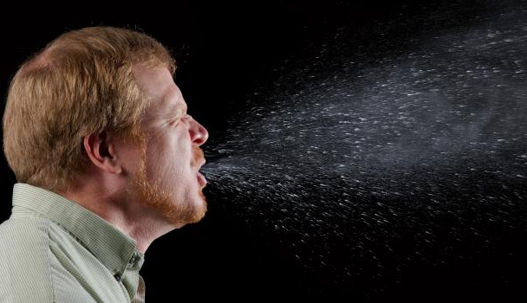

4.1.1 How is influenza virus spread?
When a person infected with influenza coughs or sneezes, they spray infected droplets from their nose and mouth. These droplets travel about 1-2 meters (3-6 feet) before landing on the surface below.
Image courtesy of Centres for Disease Control.
A person becomes infected with flu when viral particles enter their mouth, nose or eyes. This can happen in a number of ways.
- You breathe in droplets that someone has expelled (which are still “floating” in the air), or those droplets land in your mouth, nose, or eyes, OR
- You get “indirectly” infected from your own hands. You touch a surface that has been contaminated with droplets, and then touch your mouth, nose, or eyes.
About 50% of all flu infections are self-infections caused by contact with contaminated surfaces, according to the world renowned influenza expert Professor John Oxford, from the Centre for Infectious Diseases, Barts and The London, Queen Mary’s School of Medicine and Dentistry.

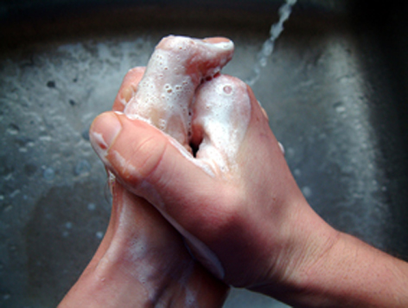
4.1.2 Hand washing
Frequent hand washing is the most important way to prevent the spread of influenza. It cannot be overemphasized: it is absolutely essential that people wash their hands correctly, and wash them often.

What is the correct method to wash hands?
- Remove all jewelery from the hands.
- Wet hands under running water.
- Apply soap to wet hands. If using bar soap, allow it to drain between uses. It is preferable to use liquid soap or small bars of soap that are changed frequently.
- Rub all surfaces of the hands vigorously for a minimum of 10 seconds.
- Rinse the hands under running water.
- Use a cloth or paper towel to turn off the tap. This prevents your hands from becoming re-contaminated.
- Dry hands with a clean cloth, disposable paper towel, or hot air dryer.
- Avoid splashing.
- If running water is not available, hands that are not visibly soiled can be cleaned with a waterless hand wash product. Follow the manufacturer’s recommendations.

When should hands be washed?
- Before, during and after food preparation
- Before eating
- After using the toilet
- After touching animals or animal waste
- After touching your nose or mouth

What about waterless hand sanitizers?
Hand sanitizers are waterless preparations, available commercially as gels, rinses and foams. Many are alcohol based (often ethanol or isopropanol, and n-propanol is available in Europe). The US Food and Drug Administration recommends a concentration of 60% to 95% alcohol (ethanol or isopropanol) for alcohol-based sanitizers. Some commercially available preparations available contain less than this amount. Non-alcohol based preparations contain benzalkonium chloride.
Hand sanitizers are not a substitute for adequate hand washing facilities (running water, soap and disposable towels or air dryers). However, they are appropriate in situations where such facilities are not available or are inconvenient for frequent use. Bottles of hand sanitizer are convenient and quick to use. By using sanitizer, employees do not have to visit the bathroom to clean their hand. However, when there is visible dirt on hands, the dirt must be removed by washing with soap and water.
If hand sanitizer dispensers are placed visibly throughout the premises, and an information campaign is carried out, the use of waterless hand rubs should generally increase hand hygiene.
Follow the manufacturer's instructions for use. The amount to use varies by product type. Approximately 2ml of a gel preparation is adequate to cover all surfaces of hands and fingers. If hands dry after rubbing for only 10 to 15 seconds, it is likely that an insufficient amount was applied.
Hand sanitizers can cause dry, stinging and or irritated skin. These problems are less common when products include skin-conditioning agents. Nevertheless, any abrasions or broken skin on the hands are likely to sting even when less-irritating formulations are used.
Disposable glove use may also interfere with hand sanitizers. Some disposable gloves are powdered on the inside, and this powder can stay on the hands after someone takes off their gloves. It may create a "gritty" residue when it comes into contact with certain alcohol-based hand rubs. Companies that are buying both gloves and hand sanitizer should test the products together before making large orders.

What about special areas, such as the food canteen?
In areas such as the food canteen, where it is vital that product (food) does not become contaminated with influenza virus, consider installing foot or knee-operated washing facilities. These reduce the chance of picking up virus on the hands when turning the water on and off.
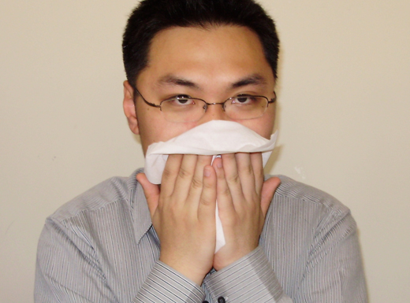

4.1.3 Cough Etiquette
Good respiratory hygiene can help prevent influenza and other respiratory illnesses from spreading. Everyone should practice good respiratory hygiene, even if they do not appear sick, since people can pass on the flu before they even show symptoms.

Respiratory hygiene
- Use a tissue to cover the nose and mouth when coughing or sneezing. If a tissue is not available, cover the nose and mouth with your upper sleeve. Do NOT use your hands, since they will get contaminated and you can easily pass on an infection by touching shared objects afterwards (doorknobs, copy machines, microwaves, etc.).
- Dispose of used tissues in the nearest waste receptacle.
- Wash your hands (or use hand sanitizer) after covering a cough or sneeze.
- In common areas, try to sit at least 1 meter (3 feet) away from coughing individuals.
- If you are sick, and must be in public, advise people not to get too close to you. Don’t shake hands.

Communicate with your employees
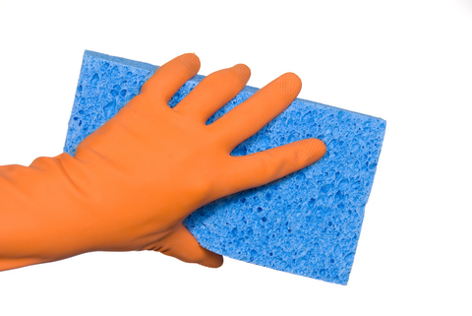
Place posters about respiratory hygiene around the workplace, and frequently remind employees about their responsibility to practice good hygiene. Communicate your expectations to your employees repeatedly and in a variety of ways (at meetings, through HR documents, in mass e-mails, etc.).

4.1.4 Contaminated surfaces and cleaning
The influenza virus can live for as long as two days on hard surfaces. Obvious examples of shared objects include telephones, faucets, toilet flush buttons, kitchen utensils, doorknobs, computer equipment (keyboard and mouse), car door handles, etc. Your facility may have specific surfaces or equipment that are used by more than one person (tools, shared reference materials, etc.).
Before an influenza pandemic starts, consider reviewing your cleaning schedules. Identify surfaces that are frequently touched by different users, as these should be disinfected more frequently in an outbreak. If feasible, plan for single-use equipment and limiting equipment sharing. Common rooms should be freed of shared objects, such as magazines and newspapers, as much as possible. Employees should also be encouraged to practice good personal hygiene in the workplace.
During a pandemic, continue regular cleaning to remove surface dirt and dust. Increasing the frequency of cleaning routines, with special emphasis on shared surfaces, may reduce the risk of spread of flu. Cleaning staff are likely to be absent, and so increased demands on their services may not be feasible. Consider which tasks can be taken on by employees for themselves, such as disinfecting their own work stations at the beginning and end of each shift. The degree to which extra cleaning is carried out should be matched to the severity of the pandemic. For example, in a mild scenario similar to seasonal flu, no extra cleaning may be warranted. However, in a severe scenario increased cleaning to three times a day may be acceptable.
Influenza virus is quite fragile and easily “killed” by regular soap and cleaning products. Disinfectants that will kill influenza include:
- Plain soap
- Any detergent
- Any disinfectant
- Household bleach
- Iodine-containing solutions
In the hospital setting, heating to 56ºC (133ºF) for 3 hours, 60ºC (140ºF) for 30 minutes or 121ºC (250ºF) for 15 minutes also inactivates influenza viruses.

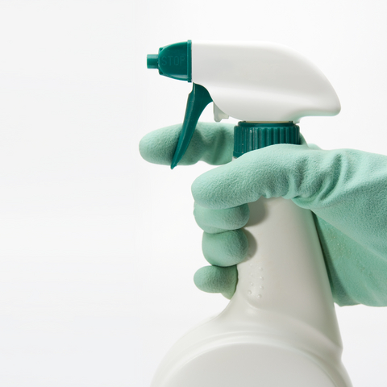
Disinfectants
A disinfectant is any product that contains chemical ingredients intended to kill disease-causing bacteria or viruses. Disinfectants are used on inanimate objects and are common for cleaning medical environments, including floors and walls. They are also used for general household cleaning.
Disinfecting products that make specific claims, such as "kills Staphylococcus aureus", must eliminate 100 percent of the organism(s) listed on the label. In the USA, these products are registered, tested and approved by the Environmental Protection Agency (EPA) http://www.epa.gov/oppad001/ad_info.htm. Some other countries have similar agencies. There are more than 500 EPA-approved products that are labeled for use against type A influenza viruses http://www.epa.gov/oppad001/influenza-disinfectants.html
Disinfectants contain potentially hazardous ingredients that may irritate skin, eyes and respiratory tract. Personal protective equipment may be required when using the products. Always check the label and follow the manufacturer's instructions. The National Institutes of Health (NIH) Household Products Database includes a list of manufacturers, ingredients listings and potential health hazards of many common cleaners.

What if someone with a suspected infection has been on premises?
In a mild scenario, ordinary cleaning procedures should be sufficient.
However, for a highly virulent virus, extra cleaning precautions can be implemented. Seal the area(s) where the suspected infected person has been and prevent others from entering. Open windows and air the room. Disinfect equipment the person may have used (pens, computer equipment, folders), or discard any disposable materials. Arrange to have a properly trained cleaning team come to the area immediately to disinfect. Include common areas the person may have used, like kitchens and bathrooms, and thoroughly clean any shared equipment, including vehicles.

Cleaning vehicles
Vehicles have many shared surfaces and should be cleaned/disinfected regularly during a severe pandemic. The following items should be wiped
- daily, if the car is used by the same person and only one person
- at each shift change, if it is a shared vehicle or
- as soon as they have possibly become contaminated
- Car door handles
- Steering wheel
- Gear stick
- Seats
- Controls, such as radio buttons, windshield wiper controls, heat/air conditioning knobs, etc.
- Any exposed car surfaces that may have been contaminated by hands or cough (windows/ dashboard)

What if a person with a suspected influenza infection has used a vehicle?
Management should prevent any other employees from using it until after it has been cleaned. Immediately arrange to have a thoroughly trained professional crew clean and disinfect the vehicle.

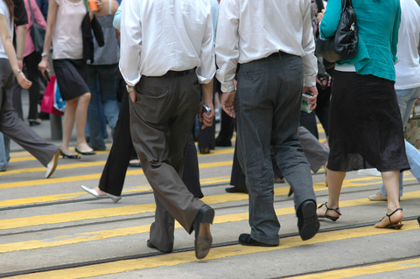
4.1.5 Social Distancing

What is social distancing?
Social distancing is a public health measure that is used to reduce spread of a pandemic virus. Its aim is to separate infected people and their close contacts from non-infected people, to reduce the risk of spreading the virus.
Social distancing is mainly effective in the lead up to a pandemic wave. Once a full pandemic wave “hits” a community, the virus will be ubiquitous in the community and social distancing is unlikely to prevent its spread.

How can social distancing reduce the risk of influenza?
The risk of inhaling the virus is decreased when people stay at a distance from infected (or potentially infected) people. Inhalation risk is significantly reduced when people stay 1-2 meters (3-6 feet) apart, but the greater the distance the better.
The risk also decreases when people reduce the number of interactions they have with others. For example, if someone remained completely isolated from other people during a pandemic, then their risk of getting infected would be extremely low. It would not be zero, however, as infection could potentially occur through a shared object.

What types of social distancing measures might be enforced by government?
Local and national governments may introduce a variety of social distancing measures leading up to or during a pandemic, including:
- Isolation (confinement) of cases: The government may recommend or mandate that all confirmed cases be isolated or confined to a particular building or location. (Locations may include a person’s home.) In many nations, the government has the power to forcibly isolate those who are suspected of suffering certain infectious diseases – including pandemic influenza. If the community is heavily affected by influenza, there may be areas designated as “influenza affected” and “non-influenza affected”.
- Quarantine of contacts: People who are close contacts infected people may be quarantined, or kept away from others, to reduce the risk of human-to-human transmission.
- Quarantine of affected areas: Public health authorities may ban travel to and from affected areas.
- Public Gatherings: In the event of a pandemic, public health authorities may issue directives to close certain venues. This may include schools (including pre-schools and tertiary education centers), work places, shopping centers and entertainment venues. Large public gatherings may also be cancelled, ranging from sports events to church services.

How can social distancing be implemented in the workplace?
Managers and employees may be able to devise social distancing measures which will be practical for their workplace. A range of approaches can be taken to reduce interactions between people and to increase the distance between people. The options depend on the type of work performed.
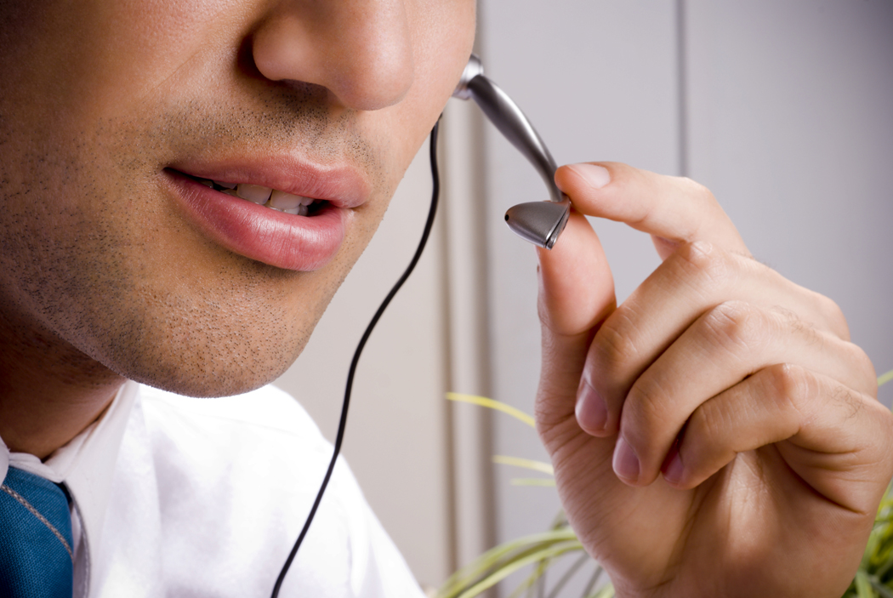
Minimize interactions between people
Review all procedures or functions where interactions can be reduced or eliminated:
- Work from home.
- Hold “virtual meetings” rather than meet face-to-face ones.
- Restrict visitors to the work place.
- Cancel group meetings and social functions.
Increase the physical distance between people
- Increase separation between workstations to at least 1 meter (3 feet). This may require reducing the production rate, opening up currently unused areas of workplace and having some people stay away from work.
- Consider dividing workers into shifts with fewer people working each shift. If shifts are already in place, introduce more shifts and reduce the number of workers per shift. Introduce shift work into offices, with a morning and afternoon session.
- Hold teleconferences or web meetings rather than face-to-face meetings, even within one office. This could allow conference rooms to convert to office space, to help increase spacing between workers.
- If in-person meetings are unavoidable, limit the number of people attending. Wherever possible, people should be seated more than 1 meter (3 feet) apart.
- Stagger any breaks such as lunch breaks. By staggering breaks, fewer people will gather at one time.

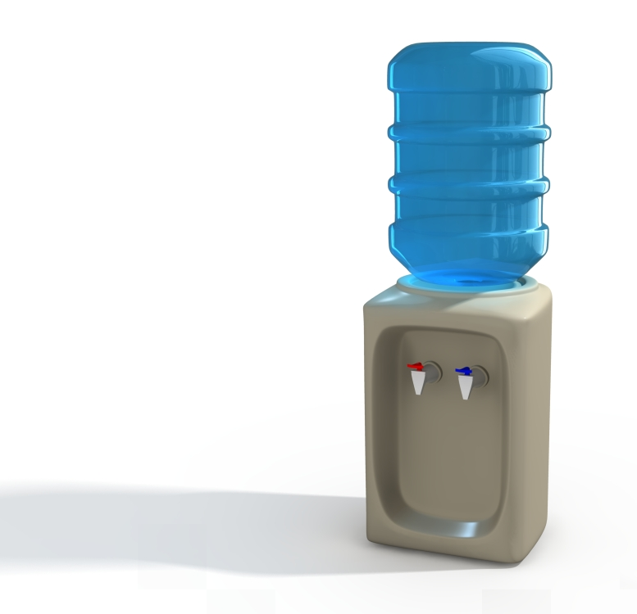
4.1.6 Water Coolers
Old fashioned water coolers sometimes have one water nozzle from which each person drinks. These could become contaminated with, and spread, influenza virus. Changing to the more hygienic form of water cooler that uses disposable cups eliminates this risk.

4.1.7 Ventilation and Air Sterilization

Can influenza be transmitted through air?
Influenza is mostly spread by infected droplets which sick people expel when they cough or sneeze. These droplets contain influenza virus. Others can catch the virus if the droplets get into their eyes, nose or mouth. In enclosed spaces that are inadequately ventilated, influenza might be spread through the air. In such environments, people could inhale the virus and become infected. This is called airborne transmission. Rooms should be well ventilated. If possible, keep windows open. Air out rooms between uses.
There is no current scientific evidence that shows influenza can be spread by
air conditioning units.

What about air conditioners?
Follow manufacturers’ instructions when installing, maintaining and cleaning air conditioner units. US CDC recommendations on air ventilation systems for health care facilities can be found at http://www.cdc.gov/mmwr/preview/mmwrhtml/rr5210a1.htm

How can air be disinfected ?
Three methods can be used to reduce the risk of airborne transmission:
- Dilution: Increased amounts of outside air are introduced into the enclosed environment. As the outside air mixes with the air inside the room, it reduces the concentration of infectious agents (such as flu virus). Dilution does not destroy the infectious agent.
Dilution can be achieved by simply opening the windows and airing a room. Mechanical ventilation devices (such as fans and air conditioners) remove indoor air and, to differing degrees, bring outdoor air inside. The rate at which outdoor air replaces indoor air is described as the air exchange rate.
- Filtration: Air is passed through a high-efficiency particulate air (HEPA) filter. It traps bacteria and viruses, thus reduces the concentration of infectious agents in the air. “True HEPA” filters are 99.97% efficient at removing particles as small as 0.3 microns from the air.
- Purifying: Ultraviolet germicidal irradiation (UVGI) is used to destroy infectious agents. As UVGI systems do not remove particulate contaminants, they are usually used in combination with dilution / filtration methods. UV radiation needs to be carefully controlled to limit human exposure. Excessive exposure causes side effects, including reddening of the skin in a sunburn-like condition and eye inflammation.
There are four types of purifying devices available, some of which are portable:
- Unprotected UV lamps without a reflector – these irradiate and sterilize air and surfaces in direct view of the lamp.
- Unprotected UV lamps with a reflector – these irradiate and sterilize air and surfaces in direct view of the lamp, and the reflector allows the UV light to be directed to a specific area.
- Enclosed UV lamps – these irradiate and sterilize the air that passes through the UV unit moved by a fan or natural air movement. These units cannot be used for surface irradiation because the light is enclosed.
- Enclosed UV lamps can also be used to sterilize water by irradiating water flow.
Examples below are for reference only. International SOS does not endorse any products and has not evaluated or verified any manufacturer’s claims.
American air and water
http://www.americanairandwater.com/al/products.htm

Dustfree
http://www.dustfree.com/

Nature’s home
http://www.4natureshome.com/

Air health
www.airhealth.com

Peak Pure Air
www.peakpureair.com

