5.1 Maintaining optimal employee health – before and during a pandemic
Contents:
5.1.1 Pandemic influenza and the healthcare system 1
5.1.2 High risk groups 2
5.1.3 What should high risk groups do? 3
5.1.4 Seasonal flu vaccination 4
5.1.5 Pandemic Flu Vaccine 6
5.1.6 Stress Management 7
5.1.7 Behavioral Health Issues During Pandemic 11
5.1.8 Behavioral health advice for families with children 13

Other supporting material for Section 5: Maintaining optimal employee health
5.4.1 POSTER L (SAMPLE) Signs of stress
5.4.2 POSTER A3 (SAMPLE) Signs of stress
5.4.3 POSTER A4 (SAMPLE) Signs of stress
5.4.4 POSTER L (SAMPLE) Take time to relax
5.4.5 POSTER A3 (SAMPLE) Take time to relax
5.4.6 POSTER A4 (SAMPLE) Take time to relax
5.4.7 POSTER L (SAMPLE) Get a flu shot each year
5.4.8 POSTER A3 (SAMPLE) Get a flu shot each year
5.4.9 POSTER A4 (SAMPLE) Get a flu shot each year

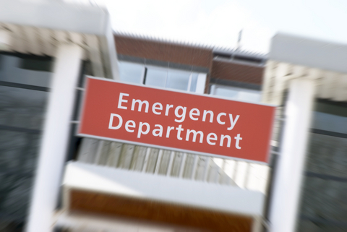
5.1.1 Pandemic influenza and the healthcare system
During an influenza pandemic, the “severity” of the virus (that is, the amount of sickness it can cause) will dictate its effect on healthcare systems. A severe virus will probably cause healthcare systems to be overwhelmed.
The 1918 Spanish flu pandemic was caused by a very severe influenza virus. It caused illness in approximately 30% of the population, and about 2% of those infected died (50-100 million globally). Healthcare systems were overwhelmed and, because of this, most of those infected had to treat themselves.
The 2009 H1N1 pandemic started as a virus of mild/moderate severity. The 2009 spring/summer wave in New York City caused over 800 people to be hospitalized. About 20% of them were admitted into Intensive Care units, and 10% required assisted breathing / artificial ventilation. Obviously, even a mild/moderate pandemic virus can increase utilization of medical services.
In developed countries, medical services – outpatient, inpatient, and intensive care – are usually “tuned” to just meet normal demand. There is usually little spare capacity. It follows that in an influenza pandemic of a “severe” virus, all forms of medical services are likely to be severely stretched or overwhelmed.
Many developing countries do not have sufficient medical services to cope with their normal, daily demands. During a pandemic, these nations will be unable to respond to the likely surge in demand for services.
As medical care may be limited, it is important that people at higher risk of having a more severe illness during a pandemic try to maintain an optimal standard of health. This includes controlling chronic conditions as much as possible. This may reduce the likelihood of them suffering complications of pandemic influenza.

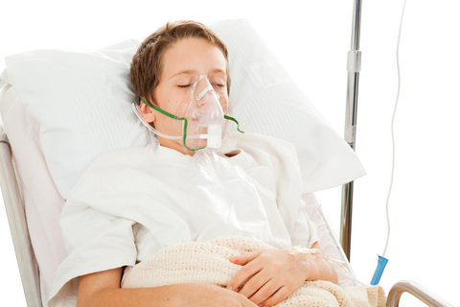
5.1.2 High risk groups
Higher risk groups have been identified for both seasonal flu and, more recently, the 2009 H1N1 pandemic.

High risk groups for seasonal flu:
Typically, seasonal flu causes more serious illness in the following groups:
- The very young (< 2 years of age)
- Older adults (> 65 years of age)
- Pregnant women
- Those with chronic diseases such as asthma, diabetes, heart disease, lung disease and compromised immune function
- Residents of chronic-care facilities, such as nursing homes

High risk groups for pandemic flu
The groups most at risk for pandemic flu can’t be determined in advance of the pandemic. However, it is assumed that at least those at higher risk for seasonal flu will be at higher risk of pandemic flu (see list above).

Higher risk groups for pandemic flu H1N1 2009 are still being determined.
As at June 2009, the higher risk groups for severe illness appear to be:

Pregnant women
- Children < 5 years
- Those with chronic diseases such as asthma, diabetes, heart disease, lung disease and compromised immune function
- Obesity
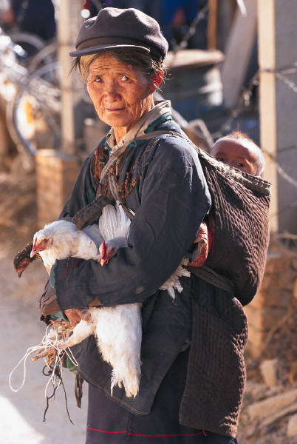
As at June 2009, people over 60 years old appear to have partial immunity to the pandemic flu H1N1. At some point earlier in their lifetime, these people may have been exposed to a flu virus somewhat similar to the 2009 pandemic strain and developed some immunity. The issue is still under investigation.

High risk groups for H5N1 avian influenza:
As at June 2009, avian flu H5N1 is not spread easily from person to person. Most infected people caught the virus via direct contact with infected birds. Avian flu H5N1 causes a very severe illness, and is fatal in about 60% of all human cases. The groups most at risk of infection are those who have direct contact with poultry.

5.1.3 What should high risk groups do?
Those with chronic medical conditions, especially if they are in a high risk group, should:
- Have regular medical reviews
- Keep their medical condition(s) under the best control possible
- Ensure that routine vaccinations are up-to-date, including:
  - Seasonal flu vaccination
  - Tetanus / diphtheria
  - Measles / mumps / rubella
  - Varicella (chicken pox)
  - Pneumococcal vaccination (if appropriate)
- Ensure that travel vaccinations are up-to-date
- Take prescribed medication as directed
- Eat a healthy diet
- Get adequate sleep and exercise
- Have up-to-date medical records stored in safe place
- Consider purchasing a bracelet identifying medical conditions
Expatriates living in locations with less-developed medical services should consider having their medical condition(s) reviewed when on leave in areas of higher quality medical care.

Notifying employers of condition(s)
Employees may wish to notify their employer regarding their chronic health conditions. Having an underlying medical condition may put the employee in a priority group for interventions, such as vaccination or evacuation. However. medical confidentiality may be an issue. Confidentiality needs to be addressed before employees reveal personal medical information.

Supplies required to manage a chronic medical condition
During a severe pandemic, supply chains may be disrupted for months. Many medical supplies (such as drugs, syringes, home testing equipment) may be unavailable during this time. Employees with chronic conditions should plan ahead and consider stockpiling important supplies – enough for a period of 2 - 6 months. If the necessary supplies must to be stored in a refrigerator (e.g. insulin) or require electricity-driven equipment (e.g. a nebulizer for asthmatics), consider purchasing a generator.

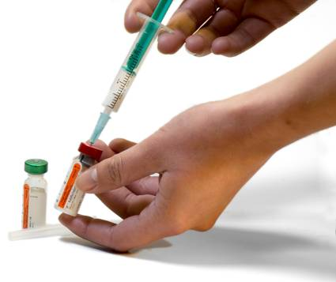
5.1.4 Seasonal flu vaccination
Seasonal influenza can be a serious disease, especially when complications such as pneumonia occur. Seasonal flu is more dangerous for those in the high risk groups (see above). Vaccination is the primary method to prevent seasonal flu and its complications. People over 6 months of age can usually be protected via vaccination.
Influenza viruses are renowned for their ability to change and evolve, and seasonal influenza virus is no different. Each year, seasonal winter flu outbreaks are caused by different flu strains. They are not usually the same as the viruses that caused the prior year’s illness. For that reason, a new influenza vaccine is developed each year to protect people against the circulating strains. Since the formula changes each year, people need to be vaccinated every year.
There are two types of flu vaccine.
- Inactivated vaccine contains killed virus and is given as an injection.
- Live attenuated vaccine contains weakened, living flu virus and is given as a nasal spray. Only healthy people between the ages of 5 and 49 years old should have the live attenuated vaccine. People outside that age range., or who have underlying medical conditions, should have the injection instead.

Timing of vaccinations
The best time to get vaccinated is before flu season starts. In the Northern Hemisphere, the optimal time is early October through mid-November. In the Southern Hemisphere, aim to be vaccinated between early March through mid-April. Although these are the ideal vaccination windows, people can also be vaccinated outside these time frames. It is still useful to be vaccinated any time during the flu season. Protection begins about two weeks after vaccination.

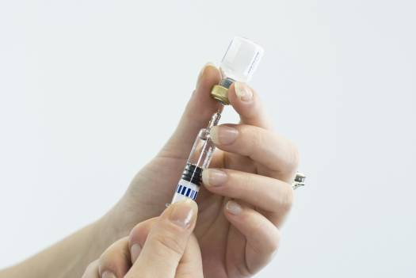
Who should have an annual flu vaccine?
Everyone should consider vaccination, especially if there are adequate supplies of the vaccine. It is especially important for the following groups, as they are most likely to suffer serious complications from flu:
- Children between 6 months and 23 months old
- Adults over 65 years old (some countries recommend for all adults over 50 years old)
- People of any age who have chronic medical conditions
- Children with underlying medical conditions or who are on chronic aspirin therapy
- Pregnant women
- Residents of communal living spaces, such as nursing homes
- People who have regular contact with anyone listed above (caregivers, medical staff, etc.)

Who should NOT have a flu vaccine?
- People who are allergic to eggs or who have had an allergic reaction to flu vaccines in the past
- Children younger than 6 months of age
- People who have a moderate or high fever, they should wait until fever subsides to get vaccinated
- The live attenuated vaccine should not be given to: people with weak immune systems, those who have chronic illnesses such as asthma or heart conditions, people on aspirin treatment, children younger than 5 years, persons older than 50 years, anyone who has had Guillain Barré Syndrome, people allergic to the vaccine or to eggs, or pregnant women

Side effects of seasonal flu vaccination
The most common side effect of the injectable vaccine is soreness and redness at the injection site. Less commonly, patients may develop a low-grade fever or muscle aches after vaccination. Serious side effects, like allergic reactions, are rare.
People who receive the nasal spray vaccine may suffer mild flu-like symptoms such as runny nose, headache, sore throat and cough after vaccination. Children may also experience muscle ache, fever and vomiting.

Does seasonal flu vaccination protect against pandemic flu?
No. Seasonal flu vaccination cannot protect people from pandemic flu. Nevertheless, annual vaccination is still recommended in order to:
- Prevent annual influenza, which can be a serious disease in its own right
- Keep people from becoming ‘mixing vessels’ for pandemic flu H1N1 and seasonal flu. If a person has both diseases at the same time, the two flu viruses could intermingle and create a new flu strain that could become more severe and infect millions of people.

5.1.5 Pandemic Flu Vaccine

Pandemic flu vaccins cannot be made in advance, as scientists do not know which flu strain will cause the pandemic until it begins. Once a pandemic starts, it takes approximately six months for a vaccine to become available. This is because the virus must be isolated, grown in chicken eggs, tested, and then distributed. (Some new technologies grow ingredients in cell lines rather than eggs, which may allow vaccine to be produced significantly sooner.) Also, vaccine manufacturers do not start making vaccine until it has been ordered.
A number of countries have “sleeping” contracts with vaccine manufacturers. These require the vaccine manufacturer to produce a certain number of vaccine doses (usually measured in millions of doses) for that country within a certain time after the contract is activated. Some of these contracts were activated by June 2009 for the H1N1 pandemic influenza.
Most pandemic vaccine made soon after a pandemic starts will be dedicated to specific governments. It is unclear – and unlikely – that pandemic vaccine will be made available to private companies to purchase for their staff soon after production begins. However, vaccine production capabilities are rapidly expanding globally, especially in China and India. It is possible that pandemic vaccine may eventually be available for private companies to purchase.
Companies should monitor the production and availability of pandemic vaccine globally. Companies should consider approaching government agencies and vaccine manufacturers to ascertain if supplies of pandemic vaccine are privately available.
Generally, people do not have any immunity to a pandemic flu strain. As such, they may need two doses of pandemic vaccine to develop good immunity to the new virus.

Avian flu H5N1 vaccine
Avian flu H5N1 has not developed the ability to spread easily from human to human, and so it has not yet become a pandemic virus. However, there is significant concern that H5N1 could develop the ability to transmit more easily and cause of the next pandemic. The illness in that pandemic may be very severe, possibly similar to the infamous 1918 “Spanish flu” outbreak.
Several strains of avian flu H5N1 currently circulate, and vaccines have been made against some of them. These are called “pre-pandemic vaccines”, as they were made even though an avian flu pandemic has not yet started. It is not certain how well they will match the avian flu virus that could eventually cause a pandemic – the virus’s genetic structure could change significantly between now and the start of a pandemic. Nevertheless, some governments have stockpiled these vaccines.
Pre-pandemic H5N1 vaccine is not available for private purchase. For more information, see the Pandemic Information Service Clinical Update “Current Developments in H5N1 Vaccines”, August 2008.

Pandemic flu H1N1 vaccine
As of June 2009, vaccine manufacturers are gearing up to produce H1N1 pandemic vaccine. It should be available in smaller quantities by August 2009 and larger quantities by December 2009. It is possible that only one dose of vaccine will be required – or two may be needed to produce good immunity. For further information see the Pandemic Information Service, Professor Oxford’s View, “Vaccine for the new influenza H1N1”, 2 June 2009.

Who will receive the pandemic vaccine first?
It is expected that governments will prioritize vaccine distribution while supplies are limited. Priority groups will be decided by each nation. It is likely that people in high risk groups and frontline staff (such as medical staff) may be the first to receive the pandemic vaccine.
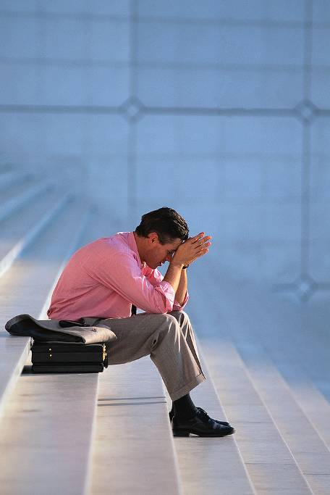

5.1.6 Stress Management

Background
Mass casualty events such as disease pandemics qualify as critical events. Critical events are disruptive incidents that involve actual or potential threat to life and are thus outside the normal daily experience. These events demand the immediate attention of the people or systems they affect. Managing critical events requires unusual energy and results in stress responses.

How can I address my employees’ fears?
Anxiety about the pandemic situation will probably lead to increased employee absence and/or increased levels of distress among employees. Some ways to manage pandemic-related stress:
- Communicate with staff early on regarding the potential pandemic and how your organization is preparing for it.
- Have a comprehensive management plan in place and make sure staff members know about it.
- Provide your staff with clear and timely information in a proactive manner.
- Once the pandemic begins, communicate clearly and accurately with staff about your organization’s response.
- Provide back up assistance for counseling staff through your Human Resources department.

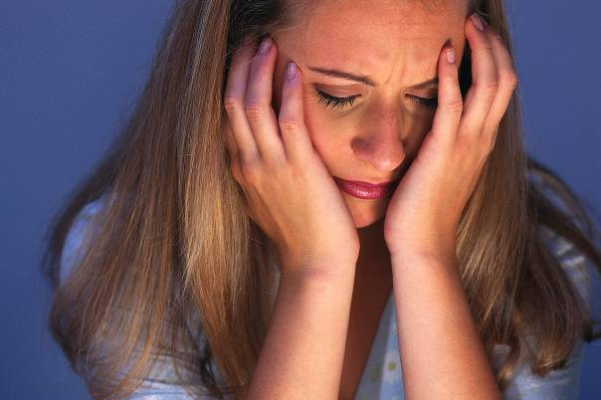
What are the signs of high stress levels?
They vary from person to person. People can recognize their individual signs by recalling a time when they felt particularly overwhelmed (perhaps when fighting with a loved one, dealing with a death, or facing a difficult decision) and trying to remember how their body felt at that time. It is useful for employees to record their personal stress signs so they can recognize, and deal with, severe stress as soon as it occurs.
Some physical examples of high stress levels include:
- Tense or aching muscles, especially in the back and neck
- Headache
- Sleep disturbances like insomnia or unusual tiredness
- Nausea/digestion problems, including constipation or lack of appetite
- Rapid heartbeat
Emotional signs of high stress:
- Difficulty concentrating
- Nervous or anxious feelings
- Increased levels of anger or aggression
- Irritability
- Sadness

What happens if stress is not effectively managed?
In the short term, the person’s productivity and quality of life decrease. Longer term unmanaged stress can lead to serious consequences such as depression, loss of self-confidence, physical ailments (exhaustion, digestive disorders), and may even contribute to the development of long-term diseases.

How can people reduce and manage their stress levels?
It is natural to suffer high levels of stress when preparing for a critical event, living during it, and recovering afterwards. One of the best things people can do is to remember that their reactions are normal responses to a highly abnormal situation, and not to judge their own stress reactions. Other ways people can manage stress include:
Exercise and eat well – Physical exertion releases body chemicals that contribute to feeling of calm and well-being. Most medical professionals recommend exercising at a moderate level for at least 30 minutes, most days of the week. Eat regular meals that include whole grains, fruits and vegetables, and low levels of fat. Avoid over-consuming caffeine or alcohol, both of which may aggravate stress symptoms.
Get enough rest – Most adults need 7-9 hours of sleep a night. Practice good sleep hygiene. Stick to a regular bedtime and wake up at about the same time each day. Sleep in a cool comfortable room. Avoid strenuous activity and upsetting books/television shows before going to sleep.
Engage in relaxing activities – Plan relaxing events into your schedule, and treat them as high priority appointments with yourself. These could include yoga, reading, chatting with a friend, listening to music, or doing deep breathing or relaxation exercises.
Actively cultivate a positive attitude - Practice positive thinking. Focus on your strengths and past accomplishments. Visualize making it through the stressful situation successfully. Create positive statements you can repeat when feeling stressed, such as “I am calm and relaxed” or “I can handle this”.
Prioritize conflicting demands - Realize you have to make choices about what’s most important. This sometimes means neglecting other things, even though they are also important. Once you decide to spend your time and energy on one thing, stick with your decision and feel good about it.

Maintain a support network – Keep in touch with family and friends. Share feelings with them and ask for help if you need it. Include them in your relaxing activities, if appropriate.
If stress symptoms do not respond to these efforts, consult a physician.
The following information particularly focuses on stress among those who work directly with critical events, such as police, medical personnel, and call center operators (collectively known as critical event responders).
Whether they are working on the ground in directly affected areas or in remote operations centers, critical event responders will be subject to unusual levels of stress. Critical event stress symptoms can occur immediately or may be delayed until the event is over.

What signs of stress are particularly prevalent among critical event responders?
The following table is not a comprehensive list of symptoms. It includes examples of what people may experience during or after a critical event, and it may help you determine if your employees are facing stress at work.
Type of symptoms | Symptoms
Physical | Sleep disturbance, nightmares, aches and pains, appetite and digestive problems, persistent fatigue, headache
Emotional | Mood swings, anxiety, depression, grief, irritability/hostility, feelings of helplessness, self-blame, feeling vulnerable, numbness, detachment, exaggerated "gallows" humor (although some of this humor is a normal coping mechanism)
Cognitive | Preoccupation with event, intrusive images, slowed thinking or racing thinking, circular thoughts, impaired problem solving, reactivation of previous traumatic events, difficulty concentrating
Behavioral | Difficulty connecting with people “outside” the critical event response system, constant talking about the event, lowered activity level, social relationship disturbances or social withdrawal, inability to rest or let go, increased use of alcohol or drugs (self-medication for depression, anxiety)
Spiritual | Loss of sense of purpose, disillusionment with future of the world, loss of perspective, seeing the event in overly personal terms


If your employees show one or several of these symptoms, you may want to take actions to reduce their stress and the stress among your staff.

How can I prevent stress from overwhelming critical event responders on my staff?
Stress reactions usually resolve on their own when the individual has good social support and is aware of helpful strategies to enhance his/her own coping ability. In addition to those listed above (under ”How can people reduce their stress levels?”), critical event responders may find it useful to:
- Talk with others about what aspects of the experience have been difficult
- Take breaks from working at regular intervals
Supervisors should enforce staff breaks during work shifts, especially for personnel who are involved in pandemic response. Breaks allow employees to better modulate their physiological response.
Staff members may need strong encouragement to take breaks, as their sense of professional and personal dedication may compel them to work through planned relaxation periods. Assure employees that breaks are in their best interest and emphasize that breaks also contribute to the organization’s effectiveness, since they help employees maintain a high level of response effectiveness.
At the end of a shift, staff should be encouraged to engage in individual or small group stress management activities. These may include physical exertion like sports, quiet time like meditation, and verbal debriefing with others.
Employees must be able to step away from event management responsibilities and cannot remain constantly on alert. Failure to recognize this need and provide downtime will have consequences for the critical event response system, most notably in accelerated staff burnout.
Advance planning and drills involving mock events can give supervisors the opportunity to educate staff in basic principles of stress management.

5.1.7 Behavioral Health Issues During Pandemic

Background
Fear is a normal response to a major crisis like a pandemic. People are naturally very concerned about their personal welfare and the health and safety of family and friends. While most people are resilient and can cope, normal responses to a major crisis can include a wide range of feelings besides fear including anger, hurt, guilt, and sadness.

How easily does fear become panic?
Fear about the pandemic situation is likely to be most acute when the public has been given reason to believe that their immediate locality is under threat, or when news has circulated that the illness threat has reached a pandemic "tipping point" suggesting global dissemination is likely. For any organization's crisis management team, it is important to know that:
- Panic by the public is very rare. If official spokespeople of the world and local health communities have done a good job of keeping the public informed about the threat and providing updates on what to do about it, the public's fears are unlikely to escalate to panic. Panic becomes more likely when the public’s trust in official sources of information has been undermined by the withholding of vital information or false reassurances.
- Initial overreaction is different from panic. Overreacting – being too vigilant, too cautious and too involved in safety planning – is common when a genuine crisis alert has just been sounded. It should be tolerated as a way of preparing, both emotionally and practically, for the new threat posed by the crisis.

- Most people are resilient in the face of fear. Once a realistic threat appears on their radar screen and they are given some opportunity to prepare (and perhaps to overreact at first), they adapt to the need to remain vigilant to threat as the "new normal".

What can I do to help people with their fear?
- Legitimize their fear as natural and understandable. Don't attempt to distinguish some fears as normal and others as irrational. Fear during crisis can attach itself to almost anything. Simply acknowledge that fear is widespread during a crisis.
- Normalize their fear by providing an example of your own fear, e.g., “Even though I was at least 50 yards from a man walking across the street from me, I felt a jolt of fear when I heard him cough."
- Normalizing fear – and confirming that it is widespread – should not go so far as attempting to allay someone's fear. Proportional fear among employees is actually the ally of the crisis manager. People who perceive a higher level of risk and have a moderate level of anxiety are most likely to take appropriate precautionary measures against infection.
- Refer people in your organization to the stress management materials included in your plan.
- Anticipate that some employees will believe that it is an appropriate cautionary measure to avoid all groups. These people will choose not to come to work, whether the policy is officially sanctioned or not. Contact them through HR to see if talking the situation over can moderate their fears.


What about people placed in quarantine?
People who are placed in quarantine during a pandemic will suffer some of the highest levels of stress. Those in institutional quarantine will be separated from family, friends, and colleagues. People undergoing quarantine in their own home will have to take on unusual and tension-producing precautions. People who are infected and recover, or even those who simply pass through a mandated quarantine period without falling ill, may be stigmatized. Negative reactions may be most notable from work colleagues, but can even occur among friends and family. The Human Resources department and other sources of support should be prepared to:
- Provide emotional aid and other forms of assistance to employees and their families during quarantine or institutional treatment.
- Discourage behavior that represents stigmatization through:
  - Early education about the epidemiology of pandemic illness.
  - Circulating an official statement periodically (by email and other channels). It should be sympathetic towards non-infected workers who feel the impulse to stigmatize out of fear, while also reiterating the epidemiologic basis of risk and practical protective measures. It should call for compassion toward those who been exposed to the illness.
- Monitor employees and their families who have been the victims of stigmatization, as they are vulnerable to developing mental health problems like high levels of anxiety, depression and post-traumatic stress.

How will response to death be different during a pandemic?
Pandemic illness will involve fatalities. It is, of course, difficult to predict which organizations will be most impacted by death among their employee ranks. What can be foreseen is that the normal process of grieving loss through group observance and memorial will be disrupted. There may not be enough space, time, or service professionals available to conduct memorials. Additionally, people may be reluctant to gather in groups – especially in groups associated with an infected individual. As this persists, several possibilities exist for helping people cope with death:
- Outline organizational policies and procedures in advance for managing employee death during pandemic.
  - Offer HR and EAP support to the immediate bereaved parties, i.e., surviving family and closest colleagues
  - Plan in advance ways that group observances might be held virtually – by telephone conference or Internet – within the limits of cultural sensitivity, appropriateness and practicality. In many instances, the most prudent plan would be planning a memorial in the future, after the active pandemic crisis in that particular region has passed. Notify people about this plan.

What about avoidable loss?
The best-laid pandemic plan can still be confronted with instances in which an employee falls ill or dies, and some people believe the company is responsible. Anger, hurt, and grief in this context have legal overtones that challenge the crisis manager. Although this may be a situation with legal sensitivity, it is incumbent on the organization to:
- Offer HR and EAP support to the immediate bereaved parties, i.e., surviving family and closest colleagues.
- Provide organizational support for employee expressions of sorrow, family sympathy and memoriam.


5.1.8 Behavioral health advice for families with children

Background
Catastrophic events like an earthquake, cyclone, fire, flood or violent acts are potentially traumatic to anyone involved. Children, as well as the elderly and people with disabilities, are especially at risk. When the disaster is pandemic illness, the challenge to psychological coping can be even greater. Unlike single-event trauma, a pandemic threatens the security of daily life and welfare for months on end. This adds another dimension to how parents must manage the emotional needs of their children.

What emotional reactions can I expect from children during pandemic?
What reactions you may see are somewhat dependent on the age of the child.
- Babies up to age 2: more irritable, cry more often and need to be held and cuddled frequently.
- 2 to 6 years: clinging to parents, fear of strangers, sleep problems (including nightmares and not wanting to sleep alone), return to bed-wetting and thumb-sucking that had been outgrown.
- 7 to 11years: sleep problems, complaints about physical problems like stomachaches and headaches, difficulties concentrating on schoolwork. May need to talk often about the details of the horrors they have seen or heard related to the pandemic.
- 12 to 18 years: some of the same reactions as younger children. Although they are more capable of verbally expressing their fears, they often want to "do something” to feel safer. Can feel an intense need to communicate with peers.


Other than being good listeners and comforting our children, what can parents do for them?
- Be aware of your own feelings first and do your best to seek support when you need it. If you are very anxious or sad, or have any other strong feeling when sitting down with your children, they are more likely to be affected by your emotional state than by your words.
- Recognize that you are a model to your children – not just for how to express and manage feelings, but also for what is important to do to enhance personal safety during pandemic. For example, be clear on the protocol you are adopting for interaction with strangers. Are you communicating through your behavior that all people outside the immediate family are potential carriers of influenza, or do you have "screening" guidelines that are easily understood by your children?
- Maintain a consistent household routine as much as possible. The familiarity of routine helps children feel more secure during times of crisis.
- Protect your children from over-exposure to media reports about pandemic but take time to talk with them about events and issues surrounding pandemic.
- Don't expect your children to be eager to talk about the "sickness everywhere" the first time you invite them to. You may have to patiently invite them to talk multiple times before they are comfortable and ready to do so.
- Ask what they have already heard about the influenza going around and what they believe it all means. As they explain what they understand, listen for misinformation, misconceptions, and underlying fears or concerns.
- Fill in the gaps in understanding at a level that is appropriate for the child's age. Share what you are doing and what other people (the government, doctors, etc.) are doing to keep them safe. Older children will usually ask for, and be able to understand, more detailed information than younger children. Every child is different, though, so take cues from your own child about how much information to provide.
- Encourage your children to ask questions and answer those questions directly. Like adults, children are better able to cope with a crisis if they feel they understand it.
- Watch for unusual behavior that may suggest your child is having difficulty dealing with the disturbing events surrounding pandemic. Refer to the age-related behavioral descriptions above for common stress-related symptoms. Consult with EAP about next steps if the symptoms or behaviors persist for a month or more.
- Be prepared to structure a variety of educational and recreational activities that stay within the boundary of your immediate household. It is possible that the wave(s) of influenza in your community will close schools, libraries, recreational centers, etc. and make it unsafe for normal socializing with the public at large.

