6.1 Managing infected employees
Contents:
6.1.1 What is the flu? 1
6.1.2 Management of a possible case influenza H5N1 (or other Phase 3 or 4 influenza) 3
6.1.3 Management of a possible case of severe influenza: 5 or 6 6
6.1.4 Isolation Rooms 11
6.1.5 Contact tracing 14
6.1.6 Management of the Deceased 17

Other supporting material for Section 6: Managing infected employees
6.2.1 PROCEDURE Contacts Tracing Script
6.3.1 COMMUNICATION Advice for Contacts of a Case Phase 6
6.3.2 COMMUNICATION Triggers for self treatment Phase 3-4
6.3.4 COMMUNICATION Triggers for self treatment Phase 5-6
6.4.1 POSTER L (SAMPLE) Is it a cold or the flu
6.4.2 POSTER A3 (SAMPLE) Is it a cold or the flu
6.4.3 POSTER A4 (SAMPLE) Is it a cold or the flu
6.5.1 TOOL Index Case Tracing Information Sheet
6.5.2 TOOL Contact Tracing Contact List (Template)
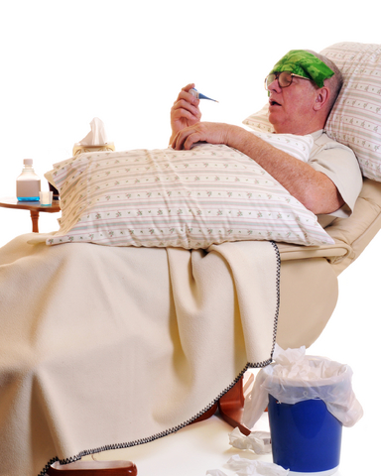

6.1.1 What is the flu?
Influenza (commonly called “flu”), is a serious respiratory illness caused by influenza viruses. Seasonal flu changes a little every year, so people never develop full immunity and can be infected more than once.
Symptoms begin suddenly and are often more severe than those of a common cold or upper respiratory infection. Although the severity of flu infections differ, most cause the following symptoms:
- Fever for 4 – 5 days (38°C/100.4°F or higher) | - Decreased appetite
- Chills (“rigors”) | - Dry cough
- Tiredness or extreme exhaustion | - Runny nose
- Headache | - Sore throat
- Muscle aches | - Mild nausea, vomiting, diarrhea (these gastrointestinal symptoms are more common in children)

If you have some of the above symptoms and not others, you may have a cold. Cold symptoms come on more gradually than flu, and they do not usually include high fever, headache, extreme exhaustion or severe muscle aches. Colds are typified by sneezing, stuffy nose, and sore throat.
Complications of the flu include dehydrations, pneumonia and sometimes death. Flu can also aggravate underlying medical conditions, such as asthma or diabetes.

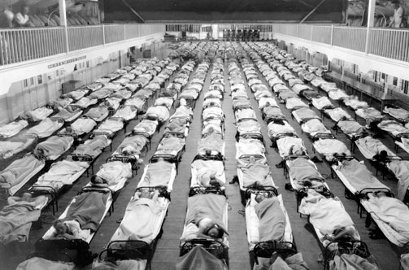
What is pandemic flu?
Image courtesy of Centres for Disease Control.
Pandemic flu is a new flu that hasn’t circulated in humans before. The majority of the population has no underlying immunity, and so the new virus spreads across the world.
We cannot know the exact symptoms of pandemic flu until the virus emerges and has been studied. However, it is anticipated that pandemic flu symptoms will mostly be similar to seasonal flu.
The pandemic influenza H1N1 2009 has symptoms similar to seasonal flu, although vomiting and diarrhea are more common with the pandemic strain.

How long is a person contagious? How long does the illness last?
Generally, people with seasonal influenza are contagious one day before they show symptoms and for about seven days after they start to feel sick. Patients typically suffer flu symptoms for 5 - 10 days.
The contagious period and duration of symptoms of a pandemic virus won’t be known until it has been studied for some time. However, it may be similar to that of seasonal flu.

How is flu prevented?
The best way to avoid seasonal flu is to have an annual vaccination. Maintain optimal health, and practice good personal hygiene.
- Cover your nose and mouth if you cough/sneeze, with a tissue. When a tissue is not available, use the inside of your elbow -not your hands!
- Stay home when you are ill.
- Avoid close contact with others (hugging, kissing). Do not share eating utensils.
- Frequently disinfect shared objects like faucets and doorknobs.
- Wash your hands frequently, and advise others to do the same.

See Section 4 “Reducing the spread of the virus between employees” and Section 5 “Maintaining optimum employee health before and during a pandemic” for more information on these topics.

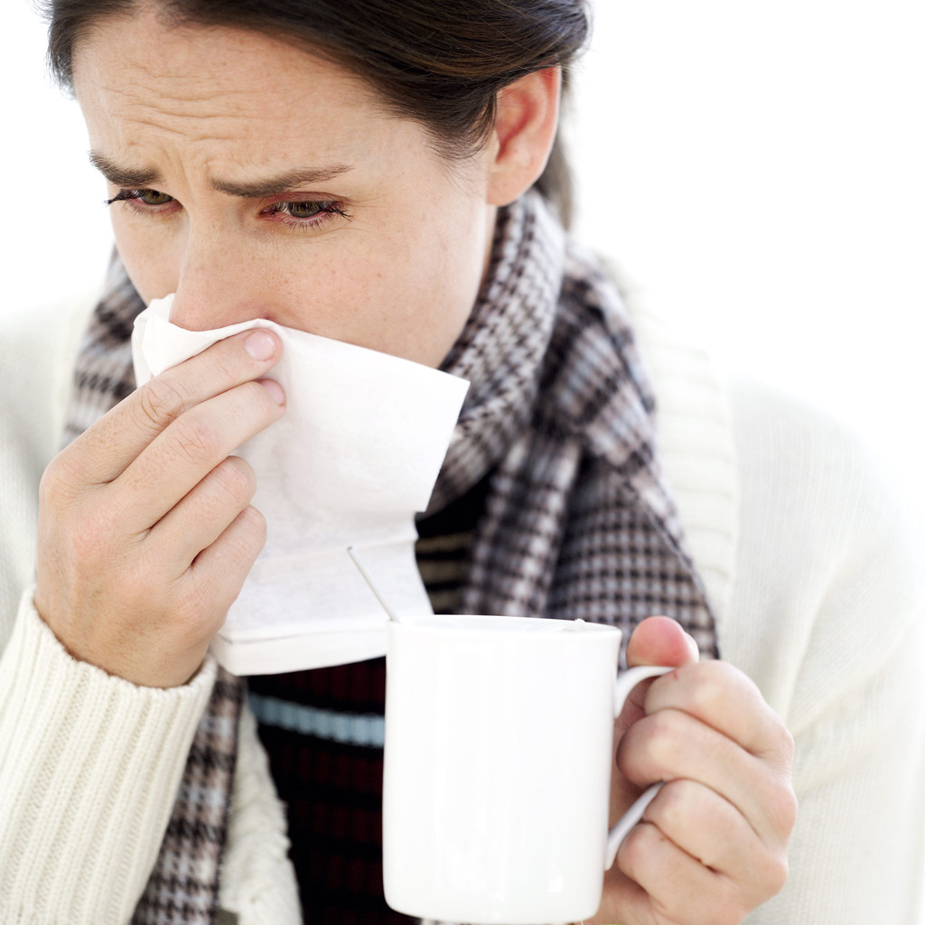
How is flu treated?
Most people who are sick with flu recover on their own, without treatment. Over-the-counter preparations can be used to ease symptoms (e.g. acetaminophen / paracetamol for fever).
Flu is caused by a virus, and thus cannot be treated with antibiotics (antibiotics treat infections caused by bacteria, not viruses). Antiviral medications can reduce the duration of symptoms by one or two days, and may reduce the risk of complications. Antivirals may also shorten then length of time an infected person is contagious. These medications must be started within 48 hours of after symptom appear to be effective. The sooner they are started, the more effective they are likely to be.

6.1.2 Management of a possible case influenza H5N1 (or other Phase 3 or 4 influenza)
As of June 2009, this section is written for Influenza H5N1 (currently at WHO Phase 3).

Local Public Health
Research any local public health procedures for dealing with a suspected H5N1 case. Know who to call and the process that must be followed.

What is the definition of a possible case of avian influenza H5N1?
H5N1
To date, all human cases of avian flu H5N1 (“bird flu”) have occurred in countries where H5N1 is circulating in poultry and/or wild birds. Most human cases have occurred in the local population who have direct contact with infected birds.
Practical case definition
- Flu-like symptoms in someone who has been directly exposed to sick birds / poultry in a country known to have H5N1 circulating in birds / poultry
New virus with pandemic potential
Details to be added here once the nature of the virus and the high risk activities are known. Monitor the International SOS Pandemic Information Service (PIS) website.

What should staff do if a suspected cases occurs?
Document any known public health procedures that should be followed here.
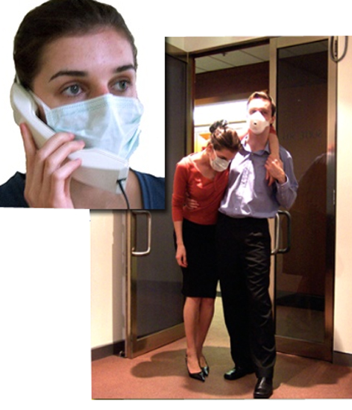
- Put a face mask on the person.
- If the person is well enough to leave immediately and independently, make arrangements for him/ her to leave the premises and be medically evaluated.
- If appropriate, the person should go home and then call the appropriate medical facility (doctor or hospital) for advice on what to do and where to go.
- If the person cannot leave independently, they should go to the room on the worksite that has been pre-identified as an isolation room.
- Staff who are attending to the ill person should wear Personal Protective Equipment (PPE).
- Limit the number of people who interact with the sick person – the fewer, the better. Minimize movement in and out of the isolation room.
- Be aware of hygiene. Wear gloves if you need to touch the person, and be sure to wash hands afterwards.
- Contact International SOS / designated doctor immediately for further advice. Arrangements will be made to collect the person and take them for further care.
- Advise the appropriate person (Influenza Manager) within your organization of the situation.

What happens next?
- The exact flow of management cannot be entirely described as it will depend on the location of the person (country, region) as well as the national processes mandated at the time. These national processes are dynamic.
- Each case needs to be dealt with individually.
- The objectives are
  - to get expert medical care as quickly as possible, while complying with public health procedures. The person may have to be taken to a designated hospital. This may be in a dedicated vehicle such as an ambulance, or it may be by private transport. The procedures may change as a pandemic situation develops.
  - to start antivirals treatment as soon as possible, if drugs are available. Must be administered under the guidance of a doctor.
  - to minimize the person’s exposure to others while making the above arrangements
  - to identify people who might be at risk of infection due to contact with the possible case, and ensure they receive appropriate medical advice and treatment (“contact tracing”).


What do we do now that the possible case has left the premises?
Any area or surface that the person has been in contact with should be cleaned:
- Keep those areas free of people for four hours if possible
- Open windows and air the room/s as much as possible
- Ensure that those who need to be notified have been informed
- Continue with contact tracing procedures, assisting public health authorities if required
- Anyone who is considered a “close contact” of the possible case should stay away from work for 7 days, and monitor their health for that period. If antivirals are available, they should be started under the guidance of a doctor.

6.1.3 Management of a possible case of severe influenza: 5 or 6
This section focuses on the management of patients / employees affected by a SEVERE pre-pandemic or pandemic virus – for example, if H5N1 develops the ability to spread easily from human to human and continues to be a severe infection.

As of July 2009, the H1N1 pandemic virus is classified by the WHO as “mild / moderate” with symptoms, in most cases, similar to seasonal flu. Although this section may be useful for H1N1 cases, it is written for SEVERE viruses.

This information sheet must be updated with the latest available information when a pandemic virus has evolved. Monitor the International SOS Pandemic Information Service (PIS) website.

Why will I have to look after a patient?
During a pandemic, especially one due to a severe virus, it is likely that health care services will be overburdened. Your usual medical provider may be overwhelmed caring for serious cases. If your family member or someone you are close to has symptoms that are mild, it may be best to avoid medical facilities and care for the patient on your own. Visiting health care facilities may further expose you and the sick person to infectious diseases. It can also provide an opportunity for your patient to pass their illness to other people.

Affected countries
- During phase 5, the flu will be circulating widely in more than one country within a single World Health Organization (WHO) region.
- During phase 6, the flu will be circulating in countries in at least two World Health Organization (WHO) regions.

Symptoms
When the symptoms of pandemic influenza are known, they should be inserted here. It is likely they will be similar to seasonal influenza. Monitor the International SOS Pandemic Information Service (PIS) website.
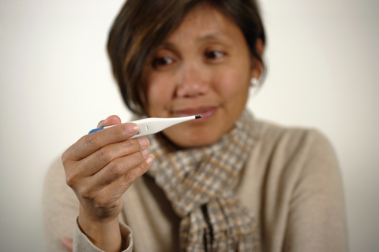
A sudden onset of a temperature over 38° C / 100.4° F
AND
One or more of the following symptoms:
- Cough
- Sore throat
- General aches and pains
- Shortness of breath
- Nausea / vomiting / diarrhea (more common in children)
Your local medical facility may have a designated influenza center that may offer testing.

Caring for someone with pandemic flu
- If antiviral drugs are available, decide whether they should be taken as soon as possible since their effectiveness is time-sensitive. If you decide to use the drugs, contact a doctor.
- Actively monitor the patient’s health. Keep a daily log of symptoms and record their temperature twice a day. Do not measure a patient’s temperature within 30 minutes of eating or drinking.
- Encourage adequate rest and plenty of sleep.
- Encourage adequate fluids (8-12 standard glasses a day, unless fluids should be restricted for medical reasons).
- If there are gastrointestinal symptoms (nausea, vomiting, diarrhea), avoid fatty, spicy or fried foods. Offer liquids frequently and soft, easily-digested foods such as biscuits, toast, bananas, rice, cooked cereal, and applesauce. Give in small portions.

Relieving the symptoms
Most symptoms will clear up by themselves. However, if necessary:
For cough:
- Use an over-the-counter cough syrup or a 50:50 honey/lemon juice mixture.
- Use a cool mist humidifier to moisten the air.
- Do not smoke. Limit or eliminate exposure to irritants and allergens (air pollution, smoke, chemicals, dust, pollen, pet dander).
For sore throat:
- Drink cold fluids, ice-sticks or honey and lemon juice in hot tea.
- Use warm salt water gargles as needed (2 teaspoons of salt in a standard glass of water).
- Suck on hard candy, herbal throat lozenges, or over-the-counter throat lozenges (sugar free if you have diabetes).
For fever or mild pain:

- Take acetaminophen / paracetamol or ibuprofen. Follow the manufacturer’s labeling for dosage.

When should the patient see a doctor?
Most people will get better without any intervention within 5 to 10 days. However, you may need to telephone a doctor for further advice. Whenever possible, phone first before going to a facility for care and let the staff know the patient may have influenza. This allows them to prepare and protect the staff and other patients. Seek further advice if:
- The person is at high risk for complications - see a doctor as soon as possible
- Antiviral drugs may be available (best taken in first 48 hours of the illness)
- Symptoms are not improving after 5 days
- Illness becomes worse after 3-5 days
- Breathing is difficult
- Coughing produces yellow / green phlegm or blood
- Vomiting is severe or persistent
- Fever is high or prolonged
- The patient is confused
- You are worried
If the patient is severely unwell, call an ambulance.

Protecting the caregiver
- If a vaccine is available, caregivers should be vaccinated.
- Keep the patient isolated, as much as possible.
- Keep contact to a minimum. Avoid close face-to-face contact (within 1-2 meters/ 3-6 feet). When you do interact with each other, consider putting a mask on both the patient and yourself. Avoid touching.
- Pay attention to hygiene. Wash your hands frequently, especially following any interaction with the patient.
- If physical contact is required, consider the use of disposable gloves and a coverall gown. Put the gown over normal clothing before attending to the patient, and then remove when leaving.
- Use post-exposure antiviral drugs, if available. Discuss with your doctor.
- Ventilate the patient’s room (that is, open the windows as much as possible).
- The caregiver should sleep in a separate room. Use separate bathrooms, if possible.
- Regularly clean rooms and equipment that the patient uses. When possible, use disposable materials instead of reusable ones (utensils, tissues, etc.).
- Keep adequate stocks of personal hygiene equipment (soap, waterless alcohol-based hand rub, tissues etc.).

6.1.4 Isolation Rooms


Purpose of isolation rooms
Isolation rooms can be used as an infection control technique both in healthcare and in private settings. Healthcare facilities use them to keep patients with infectious diseases from passing along the illness to others, or to prevent illness being transmitted to those who are very susceptible.
Offices and factories should also designate an area where people with contagious illnesses can be isolated for several hours until appropriate medical care can be arranged. This is the isolation room.
When someone on the worksite is suspected of having influenza (H1N1, H5N1, or a new strain), the reaction depends on how sick they are. If well enough, the person should be instructed to seek medical care, and arrangements should be made for them to leave the premises. If the person is too sick to leave immediately, then they should be taken to the isolation room.

How should an isolation room be equipped?
Ideally the room should be enclosed, with windows that face the outside of the building. The door should be kept closed at all times. The room should be located away from the areas that have a lot of staff and activity.
Any surface or equipment in an isolation room may become contaminated from the room’s inhabitants. Therefore, isolation rooms should only contain essential equipment that can be effectively disinfected or thrown away. Keep personal protective equipment (masks, gloves) for caregivers outside the room.
A perfect isolation room has a negative airflow pressure, though this is usually only possible in medical facilities. It is costly and impractical to create in the non-healthcare setting.
The room should have the following items:
- Sign on the door with instructions for entering and exiting the room.
- Log book at the entrance. All visitors must be recorded, with contact details, in case contact tracing becomes necessary.
- Personal protective equipment (surgical masks for the ill person, gloves and N95 respirators for attendants who need to enter the room).
- A PVC chair or couch which is easily cleaned after use.
- As little furniture and equipment as possible.
- Hand washing, toilet and bathroom facilities. If this cannot be located within the room, then designate a specific bathroom for isolation use. No one else should use this bathroom during times when someone is in the isolation room.
- Disposable tissues.
- Adequate supplies for hand washing. Alcohol-based hand rub or another alternative method for washing hands if running water is unavailable.
- First aid kit.
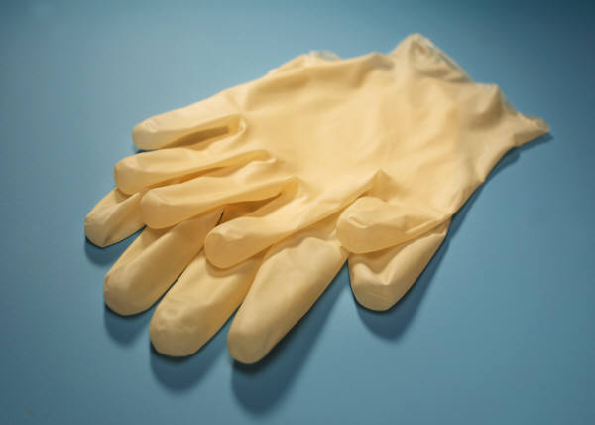
- Waste bags.

Procedures for entering and exiting the room
People must wash their hands and put on personal protective equipment (PPE) before entering the room. Once inside, shut the door and leave it closed. Remove PPE after exiting the room, and do it in the correct order:
- Remove gloves, discard into the bin.
- Wash hands.
- Remove mask by grasping the straps. Discard. Do not touch the front of the mask.
- Wash hands again.
If the ill person must leave the room, they should wear a face mask. They should not leave the room except when unavoidable (such as to use bathroom, or during transport to a health facility). Clean and disinfect the room thoroughly after use. It is recommended that trained professionals are called in to do this.

If suspected cases must remain in the isolation room for an extended period
During a pandemic, local medical services may be overwhelmed and arrangements for medical care and transportation for people in the isolation room could be delayed. If that occurs, people may need to remain in the isolation room for an extended period.
Eventually, it will become necessary to remove used items from the isolation room such as eating utensils, bedding etc. Any items that have been in the room should be treated as contaminated, and should only be handled by someone wearing appropriate PPE. Once removed from the room, objects should be disinfected immediately by trained cleaning staff.


6.1.5 Contact tracing

What is contact tracing?
This is the process of identifying people who have been in contact with an infectious person. It is an important part of controlling the spread of disease. Contacts who have been exposed to an illness may become sick themselves and/or may spread the disease to others.
Public health authorities will often perform contact tracing during disease outbreaks. Organizations should cooperate fully with these procedures. However, organizations should be prepared to implement procedures on their own in the event that public health actions are delayed.

Who is a contact?
A contact is a person who has interacted with (or may have interacted with) a person who has an infectious disease, such as the flu. Contacts have been exposed to an index case (the originally infected person) while the index case was infectious. One index case may have many contacts.
People with the flu are contagious one day before they show symptoms and remain contagious for seven days after symptoms begin.

Purpose of contact tracing
- To reduce the spread of a particular disease. Contacts who are notified of their possible infection can be treated earlier. They can also prevent spreading their infection by practicing increased hygiene measures, quarantining themselves, etc.
- Contact tracing also allows businesses to monitor the pandemic’s impact on the company. Some jurisdictions have enacted legally enforceable contact tracing and quarantine. Public health authorities may carry out contact tracing, and organizations are must assist as much as possible.

Different levels of contact
The risk of developing an illness is higher for people who had closer or longer contact with an index case. The levels of contact are as follows:
Close contacts
- People who have cared for or lived with the index case. People who had direct, unprotected contact with respiratory secretions and/or other body fluids of the index case (such as family members and health care workers) are considered to have had close contact.
Examples of close contact are kissing, hugging, sharing eating or drinking utensils, talking within one to two meters (3 to 6 feet) of the person, and direct touching. Sitting next to someone for hours in an enclosed space (such as on a plane or in a meeting room or cinema) would be considered close contact.
Close contact does NOT include activities such as walking past a person or briefly sitting across a waiting room or office.
Intermediate contacts
- Colleagues, social contacts, fellow employees who may have shared an environment for prolonged periods of time, but did not necessarily come within one to two meters (3 to 6 feet) for more than short periods.
Distant contacts
- People who were with the index case in public places and facilities for brief periods of time.


When to start contact tracing
During Phase 3, 4: If someone in your organization has a possible / probable / confirmed infection, actively trace close contacts.
During Phase 5 & 6: Consider continuing active contact tracing of close contacts. If it is impractical because of the high numbers of cases and/or contacts, change to passive contact tracing (when an index case gives a letter to their contacts) or stop contact tracing altogether.

Contact tracing process
- Collect information from the index case. It is preferable to do this on the phone or via email to avoid becoming a contact yourself.
- Record the sick person’s contacts.
- Communicate with the people who may be contacts of the index case. You must:
  - Find out if they have been in proximity of the index case. If the index case has not demanded anonymity (see “Privacy Issues” below), ask the contact to confirm the time and place where they may have interacted with the sick person.
  - If the suspected contact says they have not interacted with the index case, record this information.
  - Regardless of their exposure to the sick person, ask the suspected contact if they have any symptoms. If yes, refer to a medical team for assessment.
  - Assess the probability that the contact has acquired their infection from the index case (high / intermediate / low / none) and record this information.
When contact tracing, consider all possible routes of infection:
- The index case may have given the illness to a contact
- The index case may have acquired the illness from a contact
- The index case and the contact may have acquired the disease from a common source
- The index case and the contact may have acquired the disease independently of one another
To determine which of the above routes is most likely, ask for detailed information from both the index case and their contacts.
Note that if a contact is sick and their illness is confirmed, that contact then becomes another index case (whose contacts must then be traced). Be sure to collect all required index case information from this person.

Privacy issues
According to data protection regulations in some countries or territories (e.g. European Union), establishing lists of index cases may not be authorized as the medical criteria used to create them can be considered discriminative. Such lists are subjects to prior approval by data protection national authorities.
Index cases may request that their name not be given to contacts. Strongly encourage the index case to share information, and explain that contacts are usually asked to confirm that they have shared space with the index case. This is obviously made impossible if the index case requires anonymity. Stress that the index case has an opportunity to help others stay healthy by sharing information.
Be aware that index cases may sometimes supply inaccurate or dishonest contact information.
Also encourage the index case to perform their own contact tracing outside of the organization, notifying friends, relatives, etc. of their possible exposure.

What to do once contacts are identified
Monitor people who were at an intermediate or high risk of infection at least once a day. Check for symptoms for seven days (the incubation period for flu). Count the seven days from the contact’s most recent interaction with the index case. If the contact repeats exposure, the monitoring period is extended as it resets to day 1.

What should contacts do?
Advise them to watch for symptoms. Contacts who develop symptoms should call their doctor immediately for further advice. It is likely they will be medically evaluated, and may be started on treatment.
Sick contacts should not visit healthcare facilities unannounced, as it puts other at risk of infection. Rather, they should call ahead and tell staff that they may have the disease.
Use COMMUNICATIONS documents in this section

6.1.6 Management of the Deceased
During a pandemic (or pre-pandemic outbreak) the management of mortal remains of deceased employees may be problematic. Local undertaking providers could be overwhelmed, and government authorities may issue edicts on the management of corpses.

What is the process for management of deceased?
Notification of next of kin will have been done by designated staff within an employee's organization or by the appropriate government official from the deceased's home country. Human Resources and/or Employee Assistance Program resources to emotionally support the bereaved kin will also have been activated.
Many individuals, religious organizations and ethnic groups have specific rituals or wishes about how corpses should be dealt with. The next of kin MUST be contacted to provide direction on how to handle the body, funeral and burial. In the event that no family member is available, information should be sought in the local community.
Service providers such as International SOS can be contacted for assistance with the management of deaths in overseas employees.
The following table outlines the steps involved in processing a body. Site mangers should pre-identify local resources to assist in this process. It is hoped that the following level of detail will not be required. Countries with some form of pandemic preparedness usually have considered issues with management of the deceased. As a pandemic progresses, such countries will hopefully identify alternatives to the usual process, and may expedite some steps.

Steps | Requirements | Planning Procedures
1. Death pronounced | Person legally authorized to perform this task | Identify in advance who in your jurisdiction is able to perform this task.
2. Death certified and identity confirmed | Person legally authorized to perform this task | Identify in advance who in your jurisdiction is able to perform this task.
3. Body wrapped | Person(s) trained to perform this task  Body bags | Identify in advance who/ which organization in your jurisdiction is able to perform this task.
4. Transport to the holding area for identity and confirmation, then to morgue | In hospital: trained staff and stretcher  Outside hospital: informed person(s), stretcher and vehicle suitable for this purpose | Identify regular providers in advance.  Monitor the situation, as temporary providers may be established if regular system is overwhelmed.
5. Morgue storage | A suitable facility that can be maintained at 4 to 8° Celsius (39-46° Fahrenheit) | Identify regular facilities.  Monitor the situation, as temporary facilities may be established if regular system is overwhelmed.
6. Autopsy, if required or requested | Person qualified to perform autopsy, suitable facility with equipment. | Ensure that next of kin details are available. Next of kin must provide consent for such procedures.
7. Cremation | Suitable vehicle for transportation from morgue  Availability of cremation service.  A cremation certificate. | Identify regular facilities in advance.  Monitor the situation, as temporary procedures may be established if regular system is overwhelmed.
8. Embalming | Suitable vehicle for transportation from morgue  Trained person  Embalming equipment  Suitable location | Identify regular facilities in advance.  Monitor situation, as temporary facilities may be established if regular system is overwhelmed.
9. Funeral service | Appropriate location, casket (if not cremated), funeral director | Identify casket suppliers in advance.
10. Burial | Grave digger, space at cemetery | Identify laborers and spaces in advance.

Repatriation of mortal remains
During a severe pandemic, some expatriates and travelers will die away from their home country. Under normal circumstances, the bodies of people who die abroad can usually be repatriated for burial, and International SOS can assist. During a severe pandemic, this may become problematic as:
- There will be many such requests, stressing available resources.
- Staff of the organizations that normally handle such requests may have been affected by the pandemic.
- International borders may be closed.
Families of the deceased should be contacted to discuss the practical options. These may include local burial, local cremation, or embalming and storing the body in a vault for later repatriation.

Procedures for managing the bodies of infected individuals
In general, special procedures are not required to prevent infection when handling the body of an influenza victim. Routine standard precautions should be followed.
If mass fatalities occur, people in the community may believe that bodies must be disposed of as soon as possible. The World Health Organization (WHO) has repeatedly pointed out that dead bodies pose a minimal risk for infection. Hasty disposal of dead bodies is unnecessary, particularly if it is done without regard for the family members and their desire to bury their dead in accordance with their beliefs and customs.

