7.1 Personal Protective Equipment (PPE)
Contents:
7.1.1 What is PPE? 2
7.1.2 How is influenza virus spread? 2
7.1.3 Purpose of the different types of PPE 3
7.1.4 What PPE to use and when? 4
7.1.5 Reducing viral contamination of the environment 5
7.1.6 Guide to appropriate use of PPE (non-healthcare setting) 5
Table 7.1 SAMPLE GUIDE: Exposure to influenza virus related to job type 6
Table 7.2 SAMPLE GUIDE: PPE in an Outbreak/Pandemic of a Mild/Moderate Severity 7
Table 7.3 SAMPLE GUIDE: PPE in an Outbreak/Pandemic of a Severe Severity 8
7.1.7 Face masks 9
7.1.8 Respirators 9
7.1.9 Gloves 11
7.1.10 Eye Protection 13
7.1.11 Gowns 15
7.1.12 Powered Air Purifying Respirators (PAPRs) 16
7.1.13 Disposal of PPE 17

Other supporting material for Section 7: Personal Protective Equipment
7.2.1 PROCEDURE Influenza Risk Reduction for Front Office Staff
7.4.1 POSTER SAMPLE (L) Using Face Masks
7.4.2 POSTER SAMPLE (A3) Using Face Masks
7.4.3 POSTER SAMPLE (A4) Using Face Masks
7.4.4 POSTER SAMPLE (L) Using Respirators
7.4.5 POSTER SAMPLE (A3) Using Respirators
7.4.6 POSTER SAMPLE (A4) Using Respirators
7.4.7 POSTER SAMPLE (L) Wearing Gloves
7.4.8 POSTER SAMPLE (A3) Wearing Gloves
7.4.9 POSTER SAMPLE (A4) Wearing Gloves
7.4.10 POSTER SAMPLE (L) PPE Correct Sequence
7.4.11 POSTER SAMPLE (A3) PPE Correct Sequence
7.4.12 POSTER SAMPLE (A4) PPE Correct Sequence
7.5.1 TOOL PPE Introduction Presentation
7.5.2 TOOL PPE Calculation Matrix

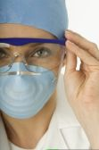
7.1.1 What is PPE?
Personal protective equipment (PPE) provides a physical barrier between a person and their environment. The more PPE covering the body, the greater that physical barrier.
There are two main reasons that PPE is used in Pandemic Planning:
- To reduce the risk of individuals becoming infected, and
- To reduce the chances of infected individuals contaminating the environment with virus and potentially infecting others.
In Pandemic Planning, the main items of PPE used are:
- Face masks
- Respirators
- Gloves
- Eye protection (goggles / shields)
- Gowns

7.1.2 How is influenza virus spread?

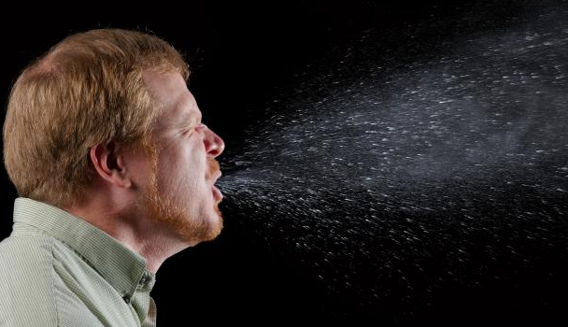
Droplet transmission:
This is the main way that influenza spreads. When a person who has the flu coughs or sneezes, droplets of virus-containing fluid (bigger than 5 microns in diameter) may be expelled from their mouth and nose. These droplets can be propelled in the air for up to 1 to 2 meters (3 to 6 feet), after which they settle. These droplets may land on inanimate objects or on other people.
Image courtesy of Centres for Disease Control.
A person becomes infected when virus-containing particles come into contact with their mouth, nose or eyes. The main ways that this can happen are:
- Inhaling droplets that a sick person has coughed or sneezed out (and are still “floating” in the air), or getting those particles into your mouth, nose, or eyes
OR
- Bringing an object that has been contaminated by virus-containing droplets (e.g. finger, mask, pen, etc) into contact with your mouth, eyes, or nose
World renowned influenza expert Professor John Oxford, from the Centre for Infectious Diseases, Barts and The London, Queen Mary’s School of Medicine and Dentistry, estimates that about 50% of all flu cases are the result of contact with contaminated surfaces.

Airborne (aerosol / droplet nuclei) transmission
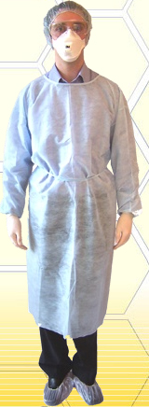
When a sick person exhales, coughs, or sneezes, they expel extremely small virus-containing droplets (less than 5 microns in diameter) into the air. The droplets are so small that sometimes they can remain airborne. These droplets can be moved by air currents, theoretically posing an infection risk to others who are more than 1-2 meters (3 to 6 feet) away. This method of transmission is thought only to be important in crowded, enclosed environments with poor ventilation (such as crowded trains with poor ventilation). Influenza virus normally is not spread through air-conditioning systems.

7.1.3 Purpose of the different types of PPE
- To reduce the risk of becoming infected, a person must reduce the chance that influenza virus comes into contact with their mouth, nose or eyes.

Face masks
- Face masks reduce the chance of virus contacting your mouth and nose. Masks prevent droplets from directly landing there, and also keep people from touching their mouth and nose with contaminated hands or other objects. General masks do not protect against very small particles which may be breathed in.
- Face masks worn by infected individuals “catch” some/most of the infected droplets created when they cough or sneeze, thus reducing viral contamination of the environment.

Respirators (N95 or P2)
- These are special masks that seal tightly over the nose and mouth. They are made of material that filters most particles from the air when it passes through the mask – as long as the respirator is correctly fitted. Most air being breathed in passes through the mask and is thus filtered, removing most or all virus particles.

Gloves
- Gloves reduce the chance that the hands will become contaminated. Disposable gloves are worn while performing a task during which the hands could become contaminated with virus.

Eye protection
- Goggles, glasses, visors, etc. reduce the chances of virus coming into contact with the eyes.

Gowns
- Gowns reduce the chance that a person’s clothes become contaminated with virus. Gowns are worn while performing a task where clothes could become contaminated with virus.

7.1.4 What PPE to use and when?
If PPE is to be used, it should be done on a VOLUNTARY basis. Staff must be appropriately trained in its use. Training includes how to put on PPE properly AND how to safely remove contaminated PPE. Review whether any national or regional workplace health regulations apply.
The following outline is intended for NON-HEALTHCARE settings, where the risk of exposure to pandemic influenza is expected to be no higher than in the general community during a pandemic.
PPE must be put on and removed correctly. The order in which it is put on and taken off is important to reduce the risk of self contamination. See the accompanying posters 7.4 for the correct technique
Companies must decide whether to provide PPE to employees. If so, they need to determine what combination of types of PPE will be provided. It depends on a number of factors, including:
- The influenza virus “severity”
  - The more severe the virus, the more important it is to protect exposed workers and prevent infected workers from spreading the virus in the workplace
- Risk of employees’ exposure to the virus while performing normal duties. Examples include:
  - Front office staff dealing with the public (e.g. receptionists, bank tellers, etc.)
  - Staff whose jobs put them in contact with the general public (e.g. train drivers)
- Risk of employee’s exposure to the virus while performing special pandemic planning-related duties. Examples include employees assigned to the following tasks, who may be more exposed and so require greater protection:
  - Point of Entry (POE) screening staff
  - Staff assigned to manage other employees who become sick in the workplace
  - Staff assigned to manage the isolation room, etc.
- The need to protect “business critical” employees
  - Some companies may have certain categories of employees who, for one reason or another, are classified as “business critical”. The need to protect these employees from infection may be a combination of:
    - Importance of their role
    - Exposure to the virus while undertaking that role, and
    - Redundancy (i.e. are there other workers who can “fill in” should certain workers become ill?)

7.1.5 Reducing viral contamination of the environment
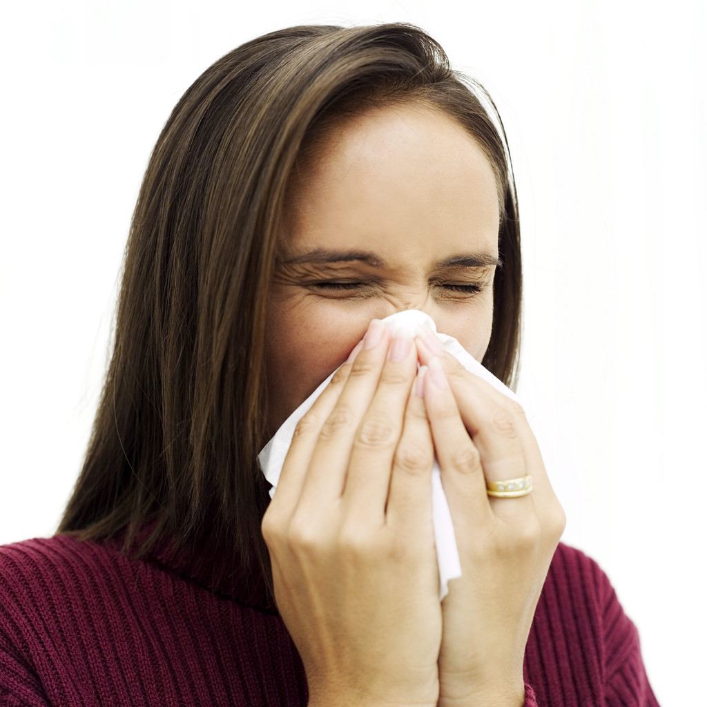
People who have the flu “spray” influenza-contaminated droplets from their nose and mouth when breathing, coughing, sneezing and talking.
Ways to reduce contamination the workplace environment include:
- Encouraging anyone who is sick to stay at home and not come to work
- Reinforcing high levels of personal hygiene
  - Hand washing
  - Covering coughs and sneezes – either with disposable tissues, or with a face mask
- Correct disposal of facial tissues and any potentially contaminated items, including PPE
- Cleaning of surfaces to remove potentially infectious droplets
- Adequate ventilation

7.1.6 Guide to appropriate use of PPE (non-healthcare setting)
Deciding when certain staff should begin using PPE, and the combination of types of PPE that they should use, is a dependent on the following variables:
- Severity of the virus
- Exposure risk related to the actual tasks performed
- Criticality of the employee or their role
- Corporate level of Duty of Care
- Corporate level of risk aversion

Tables 7.1 to 7.3 are samples and provide a guide to level of exposure to the virus related to the job. They should be used in conjunction with 7.5.4 TOOL PPE Purchasing Calculator.

Each facility should conduct its own assessment of risk of exposure.

Table 7.1 SAMPLE GUIDE: Exposure to influenza virus related to job type
Job type | Exposure to virus  (from interaction with the public or from job-related duties) | Explanation
Front office / reception | Moderate | Contact with the public. Assumed to be unable to maintain >1m (3 ft) distance from other people at some times.
POE Screening | High | Close contact with many staff and visitors. Assumed to be <1m (3 ft) from other people at most times.
Isolation room | High | Exposed to sick individuals and contaminated environment.
Cleaning | High | Staff who will carry out cleaning of potentially contaminated areas. Contact with contaminated items.
Back office / general staff | Low | Minimal contact with the public. Assumed to be able to maintain > 1m (3 ft) distance from other people at most times.

Table 7.2 SAMPLE GUIDE: PPE in an Outbreak/Pandemic of a Mild/Moderate Severity
Sonoco must adjust the settings in the table below according to its policy and intent to use PPE. Settings in this table must complement settings in your action table.

No cases reported in country |  |  |  | Cases reported in country

No cases in country |  |  |  | No local cases |  | Limited numbers of local cases | Significant or rapidly increasing numbers of local cases |  |  | No new cases in community
No cases in country |  |  |  | Cases in country  No cases in local community |  | Limited transmission in community  Gradual increase in number of local cases  May or may not be employee cases | Widespread transmission in community and/or  Rapid increase in numbers of local cases  May or may not be employee cases  Considered an AFFECTED community |  |  | No (or few) new community cases  Existing cases resolving
 | JOB TYPE | GUIDE TO PPE USE
 | Front office | -- | -- |  | -- |  |  | Face mask | --
 | Isolation room | -- | -- |  | -- |  |  | Face mask, Gloves,  Eye protection | --
 | POE Screening | -- | -- |  | -- |  |  | Face mask, Gloves,  Eye protection | --
 | Cleaning | -- | -- |  | -- |  |  | Face mask, Gloves,  Eye protection | --
 | General staff | -- | -- |  | -- |  |  | -- | --
 | Visitors | -- | -- |  | -- |  |  | -- | --

Table 7.3 SAMPLE GUIDE: PPE in an Outbreak/Pandemic of a Severe Severity
Sonoco must adjust the settings in the table below according to its policy and intent to use PPE. Settings in this table must complement settings in your action table.

No cases reported in country |  |  |  | Cases reported in country
No cases in country |  |  |  | No local cases | Limited numbers of local cases |  | Significant or rapidly increasing numbers of local cases |  |  | No new cases in community
No cases in country |  |  |  | Cases in country  No cases in local community | Limited transmission in community  Gradual increase in number of local cases  May or may not be employee cases |  | Widespread transmission in community and/or  Rapid increase in numbers of local cases  May or may not be employee cases  Considered an AFFECTED community |  |  | No (or few) new community cases  Existing cases resolving
 | JOB TYPE | GUIDE TO PPE USE
 | Front office | -- | -- |  |  | Face mask |  | Respirator, Gloves | Face mask
 | Isolation room | -- | -- |  |  | Respirator, Gloves, Eye protection, Gown |  | Respirator, Gloves, Eye protection, Gown | Respirator, Gloves, Eye protection, Gown
 | POE Screening | -- | -- |  |  | Respirator, Gloves, Eye protection, Gown |  | Respirator, Gloves, Eye protection, Gown | Respirator, Gloves, Eye protection, Gown
 | Cleaning | -- | -- |  |  | Respirator, Gloves, Eye protection, Gown |  | Respirator, Gloves, Eye protection, Gown | Respirator, Gloves, Eye protection, Gown
 | General staff | -- | -- |  |  | -- |  | Face mask in meetings | --
 | Visitors | -- | -- |  |  | Face mask |  | Face mask | Face mask

7.1.7 Face masks
Face masks may be useful in reducing droplet transmission of the flu. These masks fit loosely around the face and allow air to pass around the mask. Some face masks are approved as medical devices (by national regulatory authorities such as the US Food and Drug Administration). The approved masks provide a specific level of protection against blood and body fluids. They are known as surgical, dental, medical procedure, isolation, and laser masks.
There are a number of different designs:
- “standard surgical” type, with two sets of ties and a moldable nose bridge
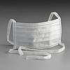 Image and Product of 3M™
- Pre-molded, held on by a single elastic band
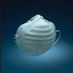 Image and Product of 3M™
- Pleated, held in place with ear loops
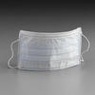 Image and Product of 3M™
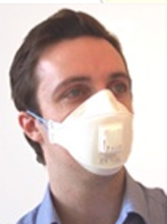
Face masks are designed for single use only and should be disposed of after use.

7.1.8 Respirators
Workplaces that have respiratory occupational hazards (for example, health care settings) must have a respiratory protection program in place. This includes a workplace risk assessment, medical evaluation, and fit-testing of appropriate masks.
This section is written for non-health care settings, where exposure to pandemic influenza is expected to be no higher than in the general population at the time of a pandemic. Respirator use is VOLUNTARY.
Review whether any national or regional workplace health regulations apply. In the US, under OSHA, the section on “Employee Voluntary Use of Respirators” may be relevant.
http://www.osha.gov/SLTC/etools/respiratory/voluntaryuses.html
This includes information which must be given to the employee.
Appendix D to Sec. 1910.134 (Mandatory) Information for Employees Using Respirators When Not Required Under the Standard
http://www.osha.gov/pls/oshaweb/owadisp.show_document?p_table=STANDARDS&p_id=9784
Respirators are “high filtration” products. The mask seals tightly onto the face so that all air passes through the mask rather than around it. Ideally, respirators should be disposed after each use. However, under certain circumstances respirators can be re-used by the same person.

What is the difference between N95 and P2 approved respirators?
Various testing and classification criteria have been developed to ensure that respirator masks meet certain standards. The two most commonly used classification systems for respirators are:

US National Institute for Occupational Health and Safety (NIOSH):
- This system gives the mask an N95 rating if it meets the required standards.

European Standards (EN):
- This system gives the mask a P2 (FFP2) rating if it meets the required standards.
There are some small differences between the testing criteria for P2 respirators and N95 respirators. P2 respirators must show 94 percent filtration under the testing conditions, while the N95 respirators must demonstrate 95 percent filtration under a different set of testing conditions. Although they have different labels, there is essentially little difference between masks rated N95 and P2.
- In some countries the government also has their own set of criteria and classification system.

Medical Clearance and Fit Testing
If a respirator is to be used to protect against a known occupational hazard, then a proper fit testing program must be in place. Workers should also be medically cleared to wear respirators.
Anyone who has a heart or lung condition should consult their doctor before using respirators.
Several respirators have been approved by the US Food and Drug Administration for use by the general public in the event of a public health emergency. These respirators do not require fit-testing. http://www.fda.gov/ForConsumers/ConsumerUpdates/ucm049295.htm

Re-use of respirators:
Respirators may be able to be reused, especially if they are in short supply. They can only be reused by the same person, not shared among different people. They can only be reused if they are properly cared for, and are not damaged, soiled, wet or contaminated. (Masks are contaminated when they have been in contact with an infected person.)
Caring for a respirator that is being reused:
If properly cared for, the respirator can last one week or more. It is to be used by the same person only, not shared. It must NOT be cleaned.
Respirators being reused should be labeled with the owner’s name and stored in a clean dry location when not in use. They may be wrapped with a dry cloth or tissue. Respirators should not be stored wrapped in plastic as this tends to retain moisture and reduce the mask’s efficacy. They should not be stored in pockets or handbags as this may crush and damage the mask, reducing its efficacy.
Do not reuse a respirator if:
- It is crushed, torn or creased.
- It is soiled or splashed with potentially infectious secretions.
- It is wet - no matter what liquid it has been wet with. Discard wet masks.
- It becomes difficult to breathe while wearing it.
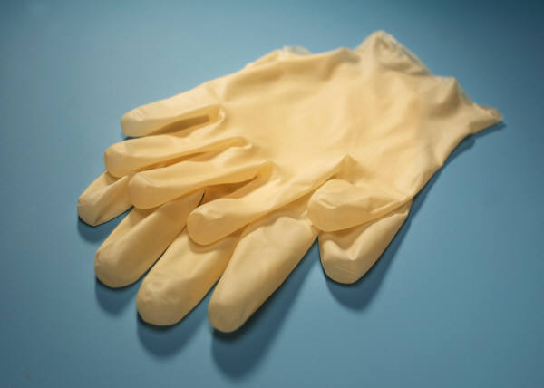

7.1.9 Gloves

Purpose of gloves
Gloves protect your hands from becoming contaminated with influenza virus.
Your hands may become contaminated if you touch objects or surfaces on which the virus has landed such as door knobs, handles on furniture and equipment, computer keyboards, desktops and work benches. Influenza viruses can remain viable on these surfaces for up to 48 hours after a sick person coughs, sneezes or otherwise expels them.
Once the virus is on your hands, you can easily become infected through everyday actions in which you touch your nose, mouth or eyes. Viruses on your hands can also contaminate every object you touch and thus pass the infection on to others.
Remember that the outside of a glove may be contaminated with virus. Refrain from touching your face with your gloves as you can infect yourself with the influenza virus.
Wearing gloves is NOT a substitute for washing your hands.

When to use gloves
Gloves are used when there is a high chance that the environment is contaminated with virus. There are many situations in which gloves may be used. Below are a few examples:
- Point of entry screening staff
- Cleaning staff
- Staff in charge of the isolation room
- People who are caring for patients who may have influenza should wear gloves when they are:
  - exposed to or handling blood and other bodily fluids, including mucous;
  - handling contaminated objects, such as clothing or blankets that have been used by an infected person;
  - cleaning a possibly contaminated space (e.g. the person’s desk, a bathroom, etc.);
  - or if the caregiver has any open wounds or broken skin on their hands.

Changing gloves
Use fresh gloves each time gloves are needed. Change the gloves if they are damaged during use. Wash hands after removing gloves, before putting on the next pair. Do not re-use gloves, even if they appear to be clean and uncontaminated. Re-using gloves puts you at high risk of contaminating your hands.

Hand washing after glove use
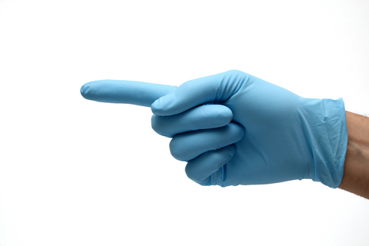
Gloves are not 100% effective in preventing hands from becoming contaminated. It is particularly easy to contaminate your hands when removing used gloves. Always wash your hands after removing gloves — including when changing gloves. There is no substitute for basic hygiene practices.

Types of gloves available
Gloves can either be sterile or non-sterile. Generally, sterile gloves are only necessary for medical procedures. In most other instances, clean, non-sterile gloves are more than adequate. These vary in price and user comfort. There are three main types of disposable non-sterile gloves.
Latex
These are the standard disposable gloves. They are suitable for most situations, although they can irritate the skin if used for long periods of time. Some people are allergic to latex and cannot use these gloves.
Nitrile
These are non-latex gloves, which can be worn by people with severe allergic reactions to latex. They are also less likely than latex gloves to cause irritation with prolonged use. They are more resistant to chemical solvents and so are sometimes described as offering an “extra level of protection”. However, for general infection control this extra level of protection is usually unnecessary. Although sometimes described as being more puncture-resistant than latex, independent trials suggest that both nitrile and latex gloves are equally durable. Nitrile gloves are more expensive.
Vinyl
Vinyl gloves are an economical choice. However, as they are not elasticized, they do not fit tightly over the hand. This can make it difficult to perform tasks that require accuracy and increases the chances that the glove will tear or puncture and possibly allow contamination. Vinyl gloves are not recommended for infection control.
Cheaper gloves will have a layer of powder on the inside which may irritate the skin if worn regularly. Powder-free gloves tend to be slightly more costly. Gloves can also be “textured” which gives them more grip to prevent objects from slipping out of the gloved hand.

Storing gloves prior to use
Keep gloves in a clean, dry location. Protect them from dust and exposure to heat.

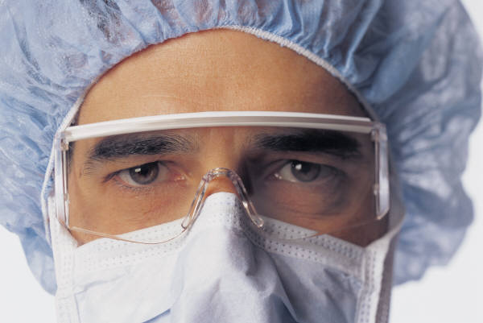
7.1.10 Eye Protection
Eye protection refers to anything worn over the eyes to help prevent them from becoming injured or contaminated. Examples include glasses, goggles, visors and face shields.
In pandemic planning, using eye protection reduces the risk of infection from influenza virus being introduced into the eye. These items should either be disposable and used only once, or disinfected between uses. Follow the manufacturer’s instructions for disinfection.
Eye protection devices should not severely impede vision and should fit securely on the face. If the re-usable type is selected, each person should have their own items. Ideally, eye protection should not be shared.

When to use eye protection
Eye protection should never be used alone for infection control purposes. It must be used in conjunction with masks and, if appropriate, other personal protective equipment (PPE) such as gowns and gloves.
Healthcare settings
During an influenza outbreak or pandemic, eye protection will predominantly be used in health care settings, especially when staff members expect to enter situations where body fluids will be splashed or sprayed.
Non-healthcare settings
Eye protection may be advisable in a non-medical workplace setting if a person could be in close contact (less than 1-2 meters / 3-6 feet away) with people infected with influenza. The situations in which eye protection may be used are similar to those in which gloves may be used.

Types of eye protection available
Glasses:
This type of protection does provide a barrier between the eyes and potentially infectious materials, but not a complete barrier. Glasses are not fully enclosed. There is open space above and below the eye. Glasses are not suitable for infection control use in a health care setting.
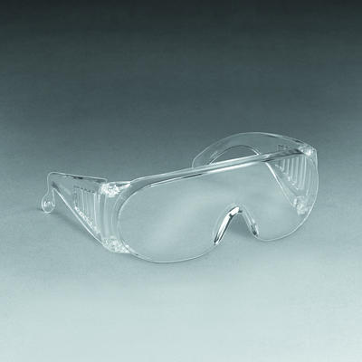 3M™ Visitor Specs - Image and Product of 3M™

Goggles
These protect the eyes and eye area against splashes and sprays, but do not protect the entire face as they leave nose and mouth exposed. They form a protective seal around the eyes. Liquids/objects cannot enter under or around them. Goggles are less comfortable than other protective devices. Though some are vented for improved comfort, these vents may compromise protective value by allowing droplets to enter the goggle/eye area.

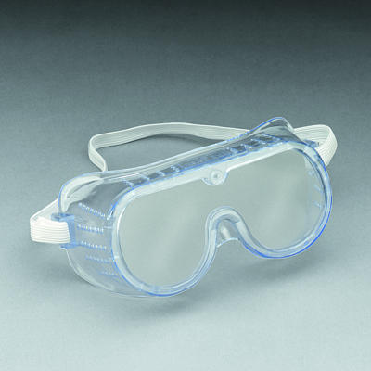 3M™ Safety Goggle - Image and Product of 3M™
Visors / Face Shield
These devices protect both the eyes and the face. They are disposable and should not be reused. Face shields are considered secondary precautions and should be used in addition to goggles for adequate protection.

Cardinal Health Secure-Gard® Visor System

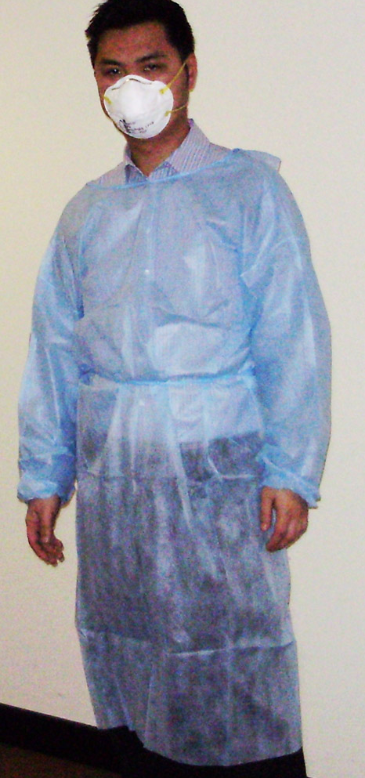
7.1.11 Gowns

What is a gown?
A gown is a garment which is worn over regular clothes, to protect your arms and clothing from contamination with influenza virus.
Gowns can be disposable or reusable. The reusable type need to be disinfected between uses. Ideally, gowns should be long-sleeved and cuffed. They should fully cover the front of the torso and arms, and tie in the back.
Gowns are not necessarily waterproof. If a waterproof shield is required, an impermeable plastic apron should be worn over the gown.

When to use gowns?
Gowns are used if high levels of PPE are required. They are usually worn in addition to masks/respirators, gloves, and eye protection. As always, high levels of personal hygiene and hand washing should be implemented.

Healthcare settings
In the healthcare setting, gowns are used to prevent cross-infection between patients and visitors, healthcare and domestic staff.
Non-healthcare settings
In non-medical facilities, gowns can provide an additional layer of protection against cross infection. However, it is unlikely that they will be required as a routine PPE item.
Gown use should be considered for the following circumstances:
- when physical contact with an infectious person is likely to occur – for example, in the “isolation room” which is designated for potentially infected persons
- when a person is at higher risk of exposure to influenza – for example, door screening staff during a pandemic situation

Types of gowns available
Reusable gowns are generally recommended for the healthcare setting only, as special laundering / disinfection needs to be carried out.
Disposable gowns come in varying levels of protection. For the non-healthcare setting, single layer types would be adequate for most uses.

7.1.12 Powered Air Purifying Respirators (PAPRs)

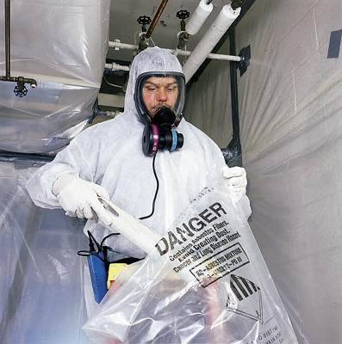
What are powered air purifying respirators (PAPRs) ?
PAPRs are motorized systems that use a filter to clean ambient air before it is delivered to the breathing zone of the user. A PAPR system typically includes a blower, battery, headpiece and a breathing tube. PAPRs are a protection against chemical, biological, radiological, and nuclear (CBRN) Agents.
PAPRs should only be considered for use under a workplace respiratory protection program. This includes a workplace risk assessment, full medical evaluation and employee education and training program.

Are PAPRs suitable against influenza ?
Protection against viruses, bacteria and other micro-organisms requires use of specialized filters. The highest efficiency is provided by a P3 filter. Therefore, to protect against airborne transmission, current advice is to use either a disposable FFP3 respirator (DEFRA, UK) with exhalation valve or re-useable respirator with P3 filter, plus close-fitting eye protection.
If facial hair or other factors will prevent an efficient seal with these respirators, use of a powered respirator (PAPR) with hood can be considered for the highest risk situations - such as in acute care hospitals.

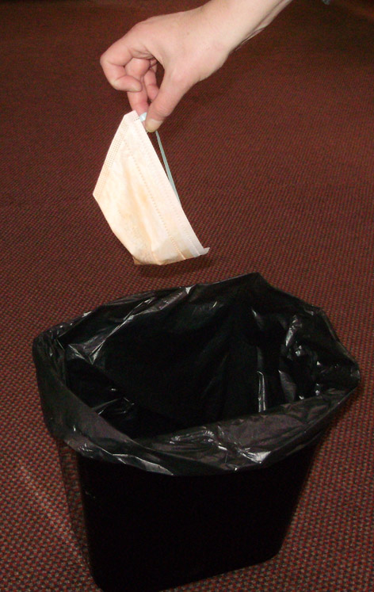
7.1.13 Disposal of PPE
Local regulations may require special disposal of used Personal Protective Equipment (PPE). The regulations governing the disposal of PPE may change over the course of a pandemic. It will be important to stay up-to-date with requirements.
Offices should comply with local regulations governing the disposal of used PPE, including face masks, gloves and gowns worn by employees and visitors. In the absence of local regulation, the following are guidelines for PPE disposal:
- All trash receptacles should have plastic liners. This includes small and large receptacles in both individual offices and in common areas.
- Masks, gowns and gloves worn by individuals with no active symptoms should be disposed of in the nearest plastic lined trash receptacle.
- Individuals who are exhibiting signs of illness are asked to exit the building. Should it be necessary to dispose of any PPE used by a person with symptoms, it is preferable to ask the sick individual to place the PPE item in a plastic bag and then dispose of the sealed bag in a plastic lined receptacle. Should it be necessary for a staff member to dispose of the used PPE, they should follow the same procedure, wearing gloves while doing so.
- Used PPE should never be left lying around. Dispose of PPE immediately upon removal.
- All cleaning staff should use appropriate PPE when cleaning. Gloves should be worn when emptying trash receptacles.
- Employees should remember to wash their hands after removing PPE.

