8.1 Antivirals
Contents:
8.1.1 What are antiviral drugs? 1
8.1.2 There are two main categories of antiviral drugs: 1
8.1.3 How are antiviral drugs used? 2
8.1.4 Pandemic Planning and antiviral drugs 3
8.1.5 National antiviral stockpiles 3
8.1.6 Developing an antiviral program for employees 4
8.1.7 The international picture 6
8.1.8 Antiviral are prescription drugs 6
8.1.7 Using Tamiflu® 6
8.1.8 Using Relenza® 7

Other supporting material for Section 8: Antivirals
8.5.1 TOOL Tamiflu Patient Informationf
8.5.2 TOOL Relenza Patient Information
8.5.3 TOOL Antiviral Policy Considerations Presentation

This reference document should be read in conjunction with Chapter 3 of the International SOS Pandemic Reference Guide: “Antiviral Medications” which provides more detailed information.


8.1.1 What are antiviral drugs?
A range of antiviral drugs are available. These do not “kill” influenza virus the way antibiotics “kill” bacteria. Instead, they slow the virus from reproducing within the body. A person with influenza who takes antiviral medication early enough will still suffer flu symptoms, but the duration of symptoms is shortened and the chance of severe illness and complications are reduced. Antiviral medication may also reduce the likelihood of spreading infection to other people.

8.1.2 There are two main categories of antiviral drugs:
- M2 inhibitors: amantadine and rimantidine
- Many influenza A viruses (including some H5N1 and some H1N1 strains) are resistant to these drugs.
- They have significant side effects and hence are not often used unless tightly medically supervised.
- They are included in some national stockpiles

- Neuraminidase inhibitors: oseltamivir (Tamiflu®) and zanamivir (Relenza®)
- They are generally easy to use, with few side effects.
- Many national stockpiles include Tamiflu, and some include both Tamiflu and Relenza.
- Tamiflu® comes as a capsule and Relenza® is an inhaled powder


8.1.3 How are antiviral drugs used?
Both Tamiflu® and Relenza® can be used for:
- Treating someone who is sick with influenza
  - The drug should be started as soon as possible -ideally, within six hours of the start of symptoms (definitely within 48 hours of symptoms, or else they may be ineffective)
- Post exposure prophylaxis
  - A smaller dose of the drug is given to someone has after they have come into contact with an infected person. This may prevent the person taking the drug from becoming sick. The person taking the drugs can still develop immunity to the flu if they were infected, even if they do not show symptoms. The drug is usually continued for 10 days after exposure to the infected person.

- Long term (pre-exposure) prophylaxis
  - A smaller dose of the drug is given for up to six weeks to prevent a person from becoming ill. If that person is exposed to influenza, they may develop immunity even though they do not become ill.
Antiviral drugs may play a part in an organization’s Pandemic Plan, through either:
- The local community healthcare providers and public health agencies – subject to local guidelines and availability
- Privately pre-arranged access to antiviral medications for an organization’s employees (a company stockpile or other antiviral program)
8.1.4 Pandemic Planning and antiviral drugs
Antiviral drugs should not be used as a single defense mechanism against pandemic influenza. The medication should be incorporated alongside other interventions (both pharmaceutical and non-pharmaceutical) as one component of a comprehensive pandemic plan.
The effectiveness of antivirals against the next pandemic influenza is unknown. Influenza is capable developing resistance to antiviral medication, and some strains are known to currently be resistant to Tamiflu. Hence the degree to which they may protect an organizations employees is unknown. The recommended doses for treatment cannot be known ahead of time, and there is a possibility that they may be in higher amounts than currently used for seasonal flu.
Nevertheless, it is anticipated that the only other pharmaceutical measure to mitigate a flu pandemic, specific vaccine, will not be available for many months after the pandemic flu strain emerges.


8.1.5 National antiviral stockpiles
National antiviral stockpiles vary in quantity and the type being held. Some countries have stockpiled more than one type of antiviral medication. Some have enough antiviral medications to provide a “treatment dose” for up to 50% of their national population. Others have stockpiled little or no medication.

Use of national stockpiles
In the pre-pandemic and pandemic period, government authorities tend to use antiviral drugs in a number of ways:
In an attempt to “contain” an outbreak geographically, or “delay” spread:
- This must be done early in the outbreak
- Treatment doses are given to infected persons
- Post-exposure prophylaxis doses are given to persons who may have been exposed to the virus
To “mitigate” the impact:
- May be used early in an outbreak, especially if medication is in short supply
- May be used after “containment” is no longer feasible, when there is widespread transmission of the virus
- Treatment doses are reserved for those with a severe illness and complications, and for those at higher risk of severe illness
- Post-exposure prophylaxis is limited to contacts who are at higher risk of severe illness
Of course, policies for anitiviral drug use vary widely between countries and governments around the world. Those with little or no medication stockpiled will not be able to use the drugs widely.


8.1.6 Developing an antiviral program for employees
In the development of an antiviral medication (AVM) program, consideration must be given to many issues. The policies behind the program, and the rationale supporting them, should be clearly documented, to ensure accountability and consistency. The policies must be accessible as they will need to be reviewed by other designated persons at a future date.
The following is a suggested checklist of considerations:
- The stockpiling of AVM is being considered as, based on current knowledge, appropriate use of AVM is expected to reduce the risk and severity of infection among staff.
- The stockpiling of AVM is being considered as only one part of a comprehensive pandemic preparedness plan. Stockpiling of AVM alone does not adequately prepare the company against the next influenza pandemic.
- Persons responsible for the policy and program:
  - Are clearly defined
  - Recognize that the use of AVM is a complex topic and agree to be fully educated on the topic of influenza and AVMs
  - Will keep up to date with developing information on influenza and AVM
  - Understand that AVM may not be effective against the next influenza pandemic, and that stockpiled AVM may expire prior to it being required
- The policies and program are to be reviewed regularly, and updated as required
- There is a process to decide on changes to the program
- Sources to be consulted for information relating to AVM are defined
- Ethical issues will be discussed (AVM is a limited resource, which may be potentially life-saving)
- Legal issues are discussed (consider whether expert advice required), and COMPANY NAME will follow the legal requirements for AVM in each country of operation
- Financial issues are discussed – cost of providing AVM will be more than just the cost of the AVM alone (additional costs to consider include cost to prescribe and store)

- Employees are provided an appropriate education program
- Who will be covered under the policy?
  - All / some staff
  - All / some dependents
  - All / some contractors
- How will medication be used?
  - for treatment
  - pre-exposure prophylaxis
  - post-exposure prophylaxis
  - or a combination of the above approaches
- The purchase and storage of AVM have been considered. The process should be :
  - Consistent across the company – where this is not possible, it should be clear that differences are due to regional requirements
  - Secure – recognizing that AVM may pose a security issue
  - Ongoing – what will be done with expired medication? Will it be replenished?

- The different methods of distribution are considered, recognizing the benefit and pitfalls of each method :
  - Immediate – Requires identification prior to the pandemic of those persons who are eligible for AVM. The employee is responsible for maintaining proper storage. Those who leave the company will retain AVM resulting in a loss of AVM and a need for re-stocking.
  - At a later date but prior to it being required – the triggers to distribute must be defined. Requires identification prior to the pandemic of those persons who are eligible for AVM.
  - At a later date when it is required– recognizing that there is a risk that the employee may not receive AVM in a timely fashion.

8.1.7 The international picture
There are strict regulations in place that govern the import and export, purchase, storage, prescription and distribution of antiviral medications. The medication must be licensed in the country of intended use. Entities must hold the appropriate licenses to perform any part in the chain of procedures, (purchase, store, prescribe, dispense) up until the medication is dispensed to the end user. These regulations vary between countries, and at times even within countries.
The three distribution methods for antiviral medication mentioned above are theoretically possible. However, in a given location, regulations may permit none, one, two or all three methods.

8.1.8 Antiviral are prescription drugs
Antivirals are usually available by prescription only, although there are a few exceptions in some countries. During a pandemic, under special regulations, some countries may allow pharmacists and nurses to provide antiviral medications to sick persons without requiring a doctor’s visit/prescription. In addition, public health authorities may issue guidelines for use. Guidelines may change as the pandemic evolves.

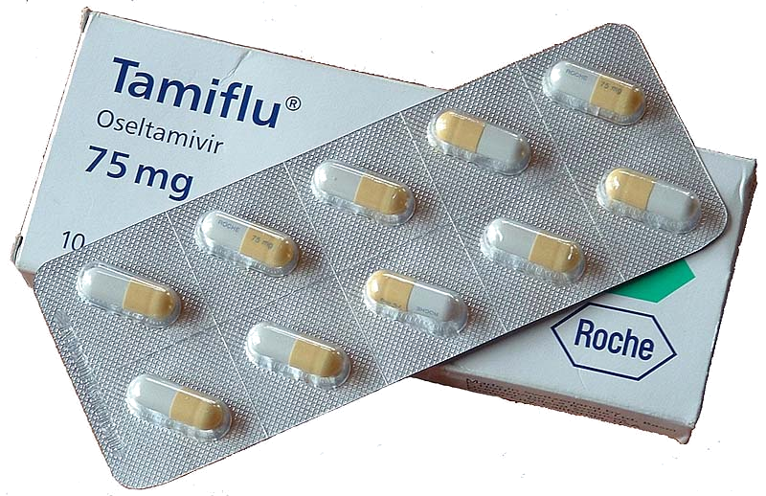
8.1.7 Using Tamiflu®
Tamiflu is available as a 75 mg capsule. Special formulations (suspension or lower dose capsules) are available in some regions. Always follow instructions given by the prescribing doctor, and refer to the manufacturer’s package insert.

Treatment
The usual adult dose for treatment is one capsule (75mg) twice daily, for 5 days. Dosage is adjusted for children.

Prophylaxis
Tamiflu® may also be used as prophylaxis, to prevent people from becoming infected either before or after exposure to influenza. The usual adult dose is one capsule (75mg) once a day, for 10 days following exposure, or for the duration of exposure, up to 6 weeks.

Who should not take Tamiflu®?
Anyone who is allergic to oseltamivir phosphate (the main ingredient), or any of its other ingredients. It is not usually recommended during pregnancy, breastfeeding, or for children younger than 1 year, although some guidelines may be changed during a pandemic.

What are some side effects?
Nausea and vomiting occur in about 10% of people taking the medication. This may be less of a problem if the drug is taken with food. Other side effects can occur. Consult the manufacturer’s information.

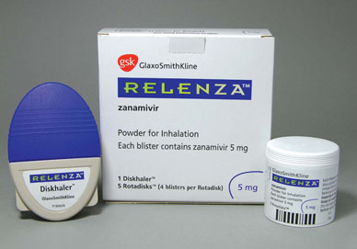
8.1.8 Using Relenza®
Relenza is available as a powder which is inhaled via a device called a “diskhaler”.
Always follow instructions given by the prescribing doctor, and refer to the manufacturer’s package insert.

Treatment
The usual dose for treatment for adults and children over 7 years old, is an inhalation of two “blisters” (10mg) twice daily. The usual treatment course is 5 days. The age at which the drug is approved for use varies between countries.

Prophylaxis
In some countries, Relenza® may also be used as prophylaxis to prevent infection either before or after exposure to influenza. The usual preventative dose is an inhalation of two “blisters” (10mg).once a day, for 10 days following exposure or for the duration of exposure.

Who should not take Relenza®?
Anyone who is allergic to zanamivir (the main ingredient), or its other ingredient, lactose powder (which contains milk proteins). It is not usually recommended during pregnancy or breastfeeding, although some guidelines may be changed during a pandemic.
Relenza® is not recommended for people with underlying lung conditions such as asthma or chronic obstructive airways disease, as it has been known to trigger serious wheeze and bronchospasm.

What are some side effects?
Nausea, diarrhea, dizziness and headache can occur. Severe reactions of wheezing and bronchospasm can occur in some people even if they do not have underlying lung disorders (such as asthma or chronic obstructive airways disease). This severe reaction can be fatal. Other side effects can occur. Consult the manufacturer’s information.

