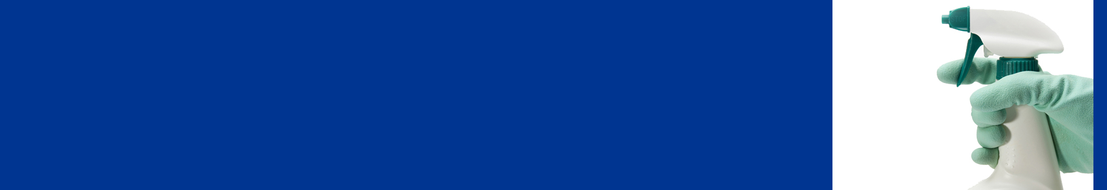
Cleaning contaminated areas

Seal off any areas that have been used by someone who might have the flu and disinfect as soon as possible.

When cleaning:
- Wear disposable gloves.
- Avoid methods that re-aerosolize particles, such as compressed air.
- Use as little equipment as possible – this prevents contaminating lots of cleaning implements.
- Wash hands after removing gloves.

Disinfection process
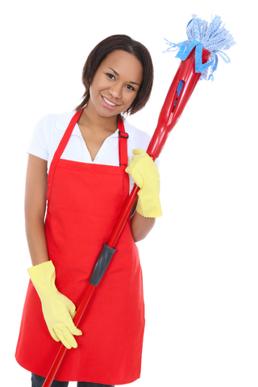
- Open windows to increase ventilation.
- Spray room with disinfectant.
- Mop floor with sodium hypochlorite 0.1% (1000ppm).
- Wipe frequently touched items (keyboards, mouse, switches, etc.) with sodium hypochlorite solution.
- Wipe metal objects with 70% alcohol solution.
- Wipe blinds and walls (up to 3 meters height) with disinfectant.
- Remove curtains and launder.
- Wipe down frequently touched surfaces (tables, chairs, door knobs, etc.) with chemical disinfectant.
- Allow items to air dry.
After cleaning an area:
- Change dirty water for clean before moving on to clean somewhere else.
- Disinfect cleaning equipment used, including buckets.

