
Don’t spread sickness!

1 | Wash your hands  Wash regularly with soap for at least 10-20 seconds. Do it after you sneeze or cough, after you use the bathroom, before you eat, and before you touch your eyes, nose or mouth. | 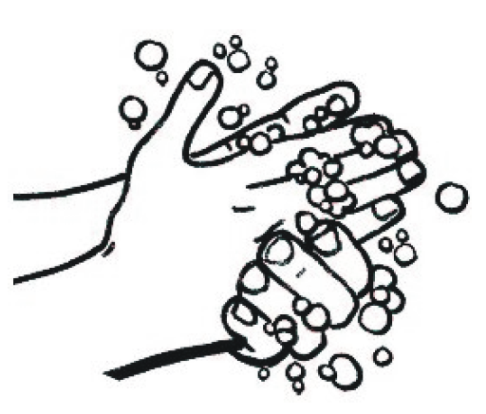

2 | Cover your cough  When you cough or sneeze, cover it with a tissue or with the back of your sleeve. In some cases, you may need to wear a mask to protect others. Always throw used tissues in the bin. | 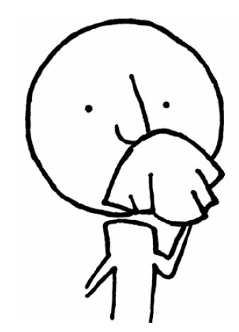

3 | Stay at home if you  feel sick  Rest at home until you feel better. Avoid seeing too many other people. | 