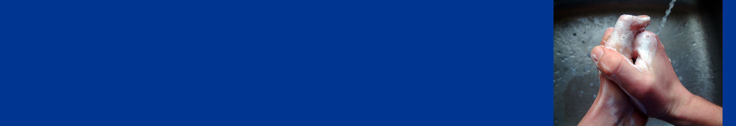
Wash Your Hands

Wash for at least 10 – 20 seconds

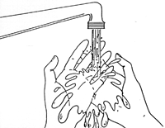 |  | 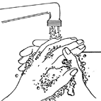 |  | 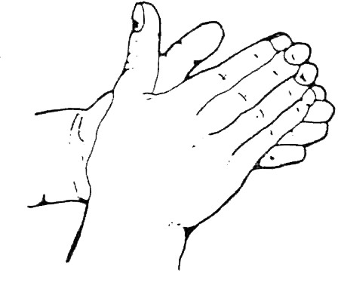
1 | Remove all jewelery and wet hands with warm water | 2 | Apply soap to hands | 3 | Rub hands together
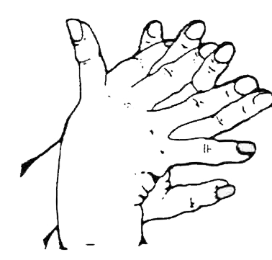 |  | 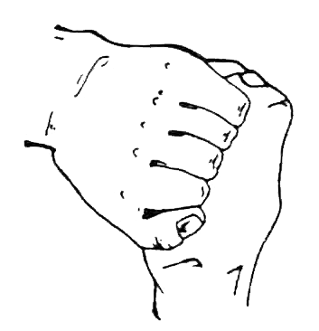 |  | 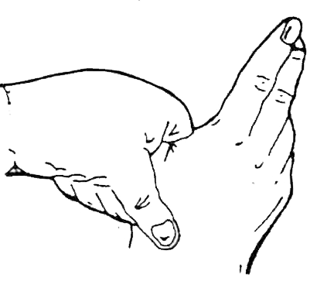
4 | Cover all surfaces of the hands and fingers | 5 | Clean knuckles, back of hands and fingers | 6 | Clean the space between the thumb and the index finger
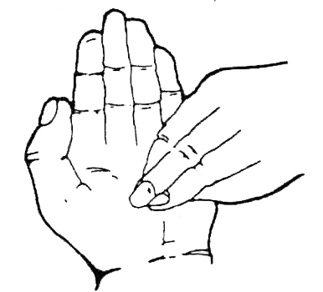 |  |  |  | 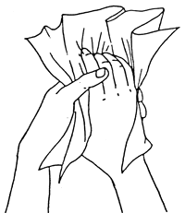
7 | Clean the fingernails by working the fingertips into the palms | 8 | Rinse well under warm running water | 9 | Dry with a disposable paper towel, then use the towel to turn off the tap

