
Keep it clean!

Reduce the risk of spreading flu
by following these guidelines.

Use normal supplies
- Most detergents or disinfectants kill influenza – no special solutions required!
- Use regular household detergents like hand soap or dish/laundry detergent.
- Bleach or alcohol also works to disinfect and sanitize.
Clean often
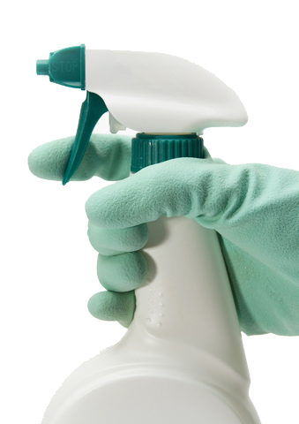
Wipe shared objects and work areas daily, or more often if you think they’ve been contaminated.
- Phones
- Computers (screen, keyboard, mouse)
- Desks and counters
- Chairs and arm rests
- Light switches
- Temperature controls (thermostat)
- Buttons on photocopier, fax machine
- Door handles
- Conference room equipment
- Toilet flush buttons

