
PPE: The correct sequence
Putting it on, and removing it

Only wear clean PPE
Always follow manufacturer’s instructions

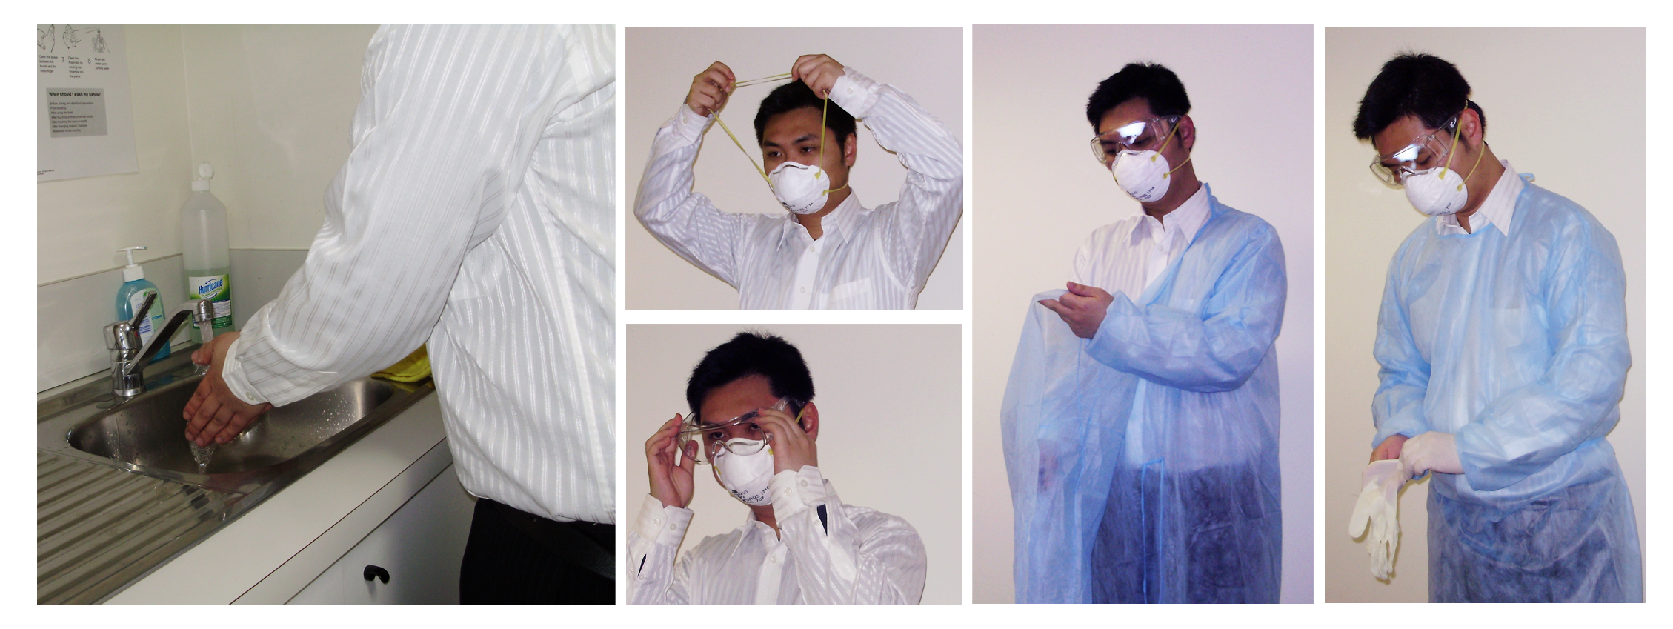
Steps for putting on PPE
- Wash your hands
2
- Put on your respirator/ mask
- Put on your eye protection
- Put on your gown
4
5
- Put on your gloves
1
3
4
5

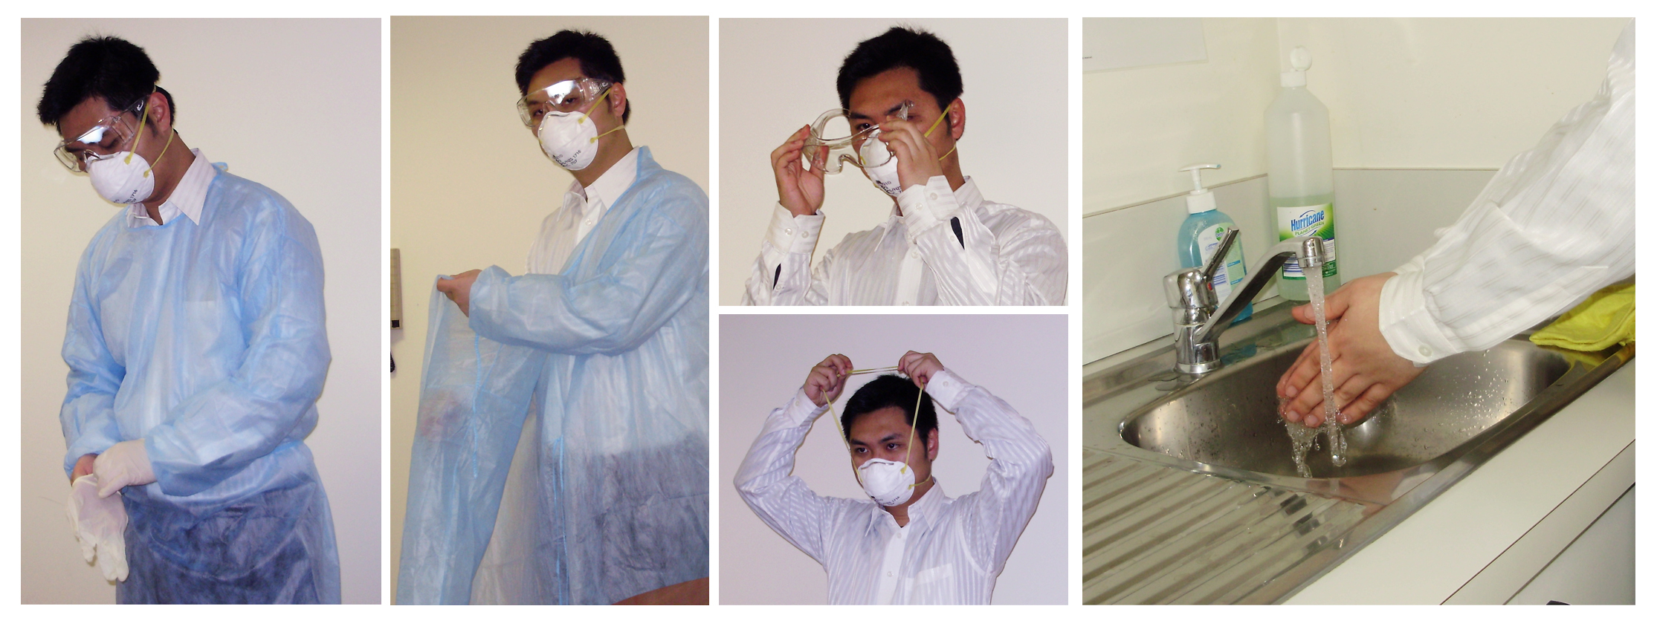
Steps for removing PPE
- Take off your gloves
3
- Take off your gown
- Take off your eye protection
- Take off your respirator/mask
4
5
- Wash your hands
1
2
4
5

