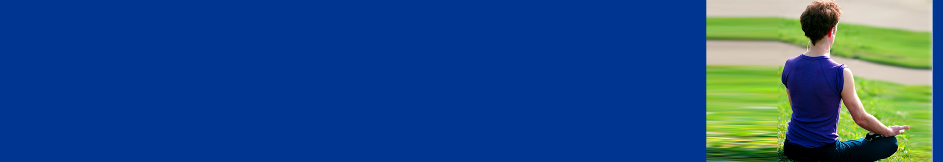
Take time to relax

Dealing with a pandemic situation can be extremely stressful. Taking time out to relax is very important. You may find the following techniques helpful.
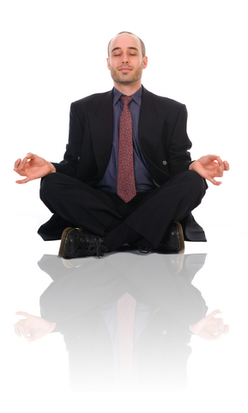

Deep breathing
- Breathe in through your nose.
- Let the air fill your whole chest cavity, through the bottom of your lungs and right down into your stomach.
- Breathe out slowly. Concentrate on letting all your muscles relax.

Focused breathing

Breathe in through your nose.
- As you breathe out, say a positive statement to yourself like “relax” or “calm down”.

Visualization

Begin breathing slowly through your nose and close your eyes.

Picture a pleasant place. It can be anywhere you like. Imagine the pleasant sights, sounds and smells. Feel the temperature, notice the colors – details help make it feel more real and more relaxing.

Progressive muscle relaxation
- Loosen any constrictive clothing. Remove your shoes. Then sit or lie down comfortably with your eyes closed.
- Work one muscle group at a time. Deliberately tighten up the muscles, and hold for 10 seconds. Then release the hold and let the muscles go loose. As you tighten and relax each muscle group, pay attention to the difference in sensations between tension and relaxation.
- Begin with your feet and work up through your legs, stomach, chest/back, fists, arms, neck and jaw to your forehead. Or try it from the top down.
- If some parts of your body are still tight after a session, repeat the exercise concentrating on those areas.

