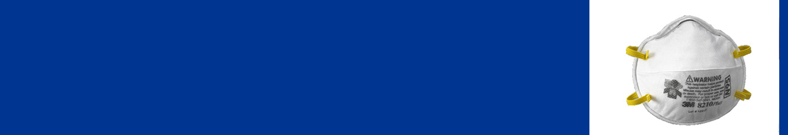
Using Respirators

Only wear a clean respirator.
Do not re-use disposable products.
Always follow the manufacturer’s instructions.
How to put on a respirator
Wash your hands before putting on your respirator.
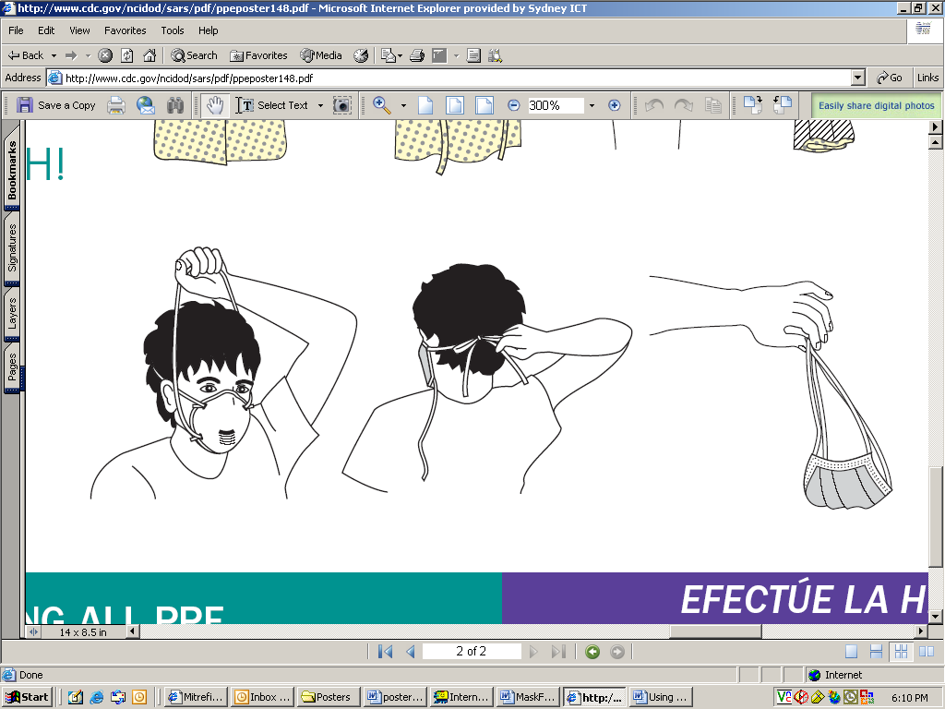
Long hair must be tied back. Face must be clean-shaven (no facial hair).
- Place the mask over the nose and mouth.
- Pull the top strap over your head and position it at the back of your head, with the strap above your ears.
- Pull the bottom strap over your head and position it at the back of your neck, with the strap below your ears.
- Shape the nose clip to the bridge of your nose.
- Make sure the mask fits snugly around the face. Perform a seal check.
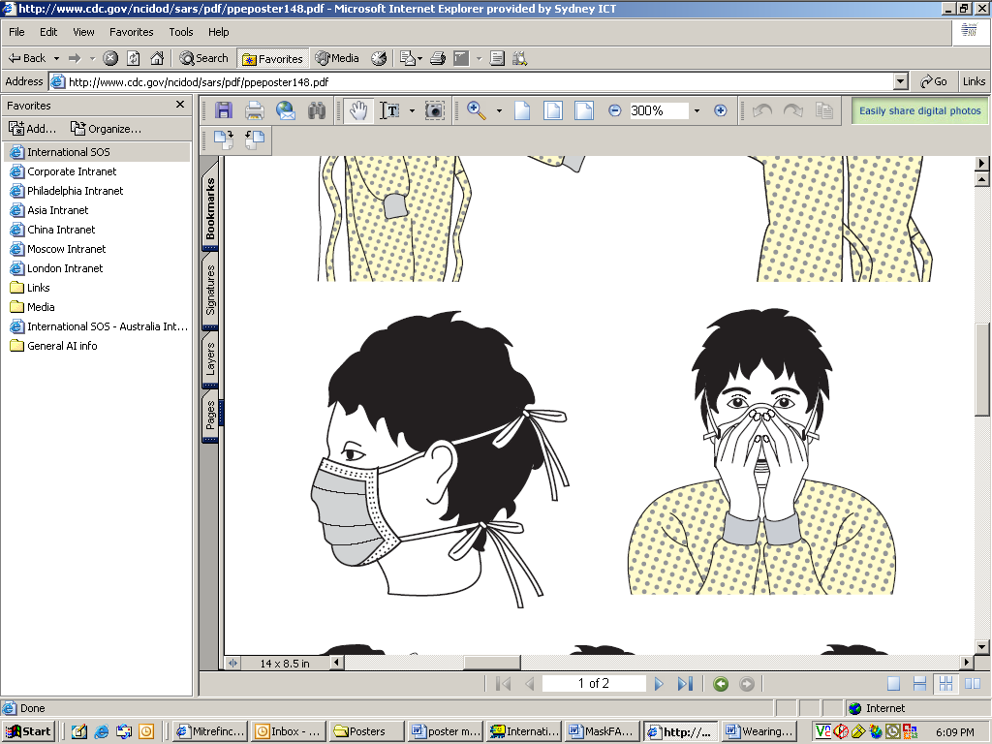
Perform a seal check
- Cup both hands over the front respirator.
- If wearing a non-valved respirator – exhale sharply.
If wearing a valved respirator – inhale sharply.
- Air should not leak around the mask. If it does, mold the nose clip again and reposition the straps.
How to remove a mask
The front of the mask or respirator may be contaminated – DO NOT TOUCH IT.
- Wash your hands.
- Grasp the mask ONLY by the straps. Pull the strap at the back of your neck over your head, then pull off the top strap.
- Dispose of the mask.
- Wash your hands.

