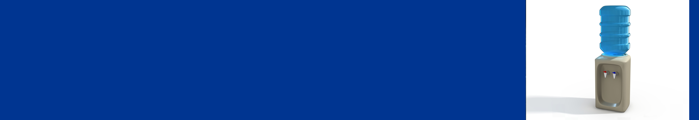
Using the Water Cooler

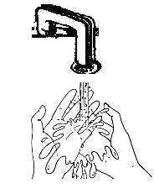 |  |  | 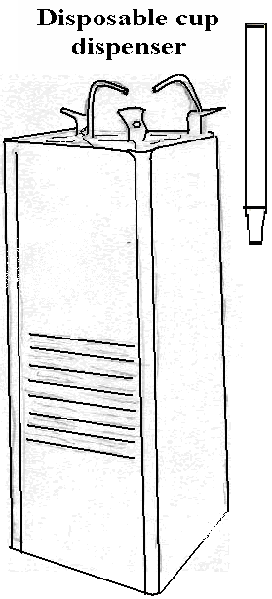 |  |  | 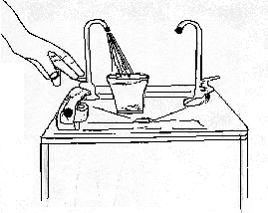  DO NOT TOUCH
1 | Wash your hands before you use the water cooler. |  | 2 |  | Take a disposable cup from the dispenser. | 3 |  | Use the cold or hot water faucet to fill up the cup. Do NOT touch anything else.
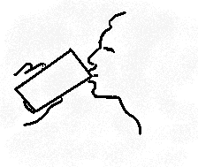 |  |  | 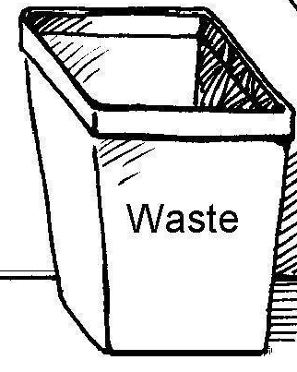
4 | Drink water from the cup. Do NOT place your mouth directly over the faucets or the “bubbler”. |  | 5 |  | Throw the disposable cup in the waste can. | 6 |  | Wash your hands after you drink water.
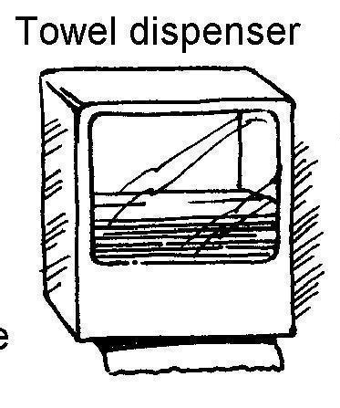 |  | 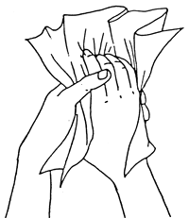
7 | Take a disposable paper towel from the dispenser. | 8 |  | Dry your hands with the paper towel. |  | 9 | Throw the used paper into the waste can.

