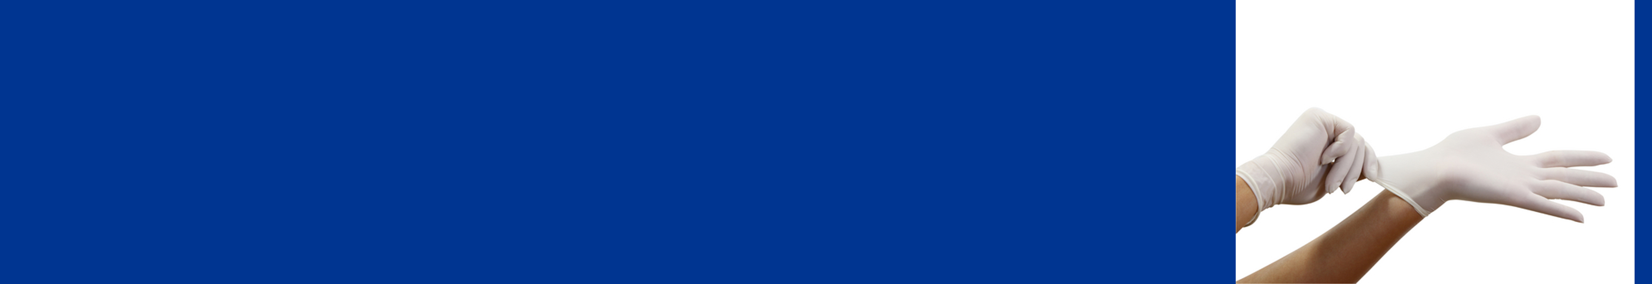
Wearing Gloves

When to wear gloves
- If handling, or exposed to, bodily fluids.
- When handling or disinfecting anything that might be contaminated with flu virus (a sick person’s clothes, blankets, desk, car, used tissues, etc.).
- If you have any cuts or broken skin on your hands.
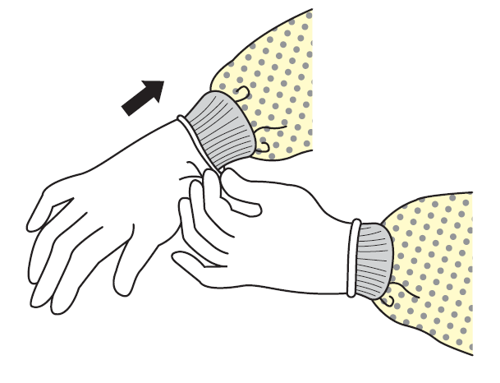
- If touching someone who might be infected.

How to put gloves on
Pull them on and extend to cover the wrist.

How to take gloves off
Remember the outside of gloves might be contaminated!
- Grasp outside of one glove with opposite, gloved hand. Peel off.
- Hold the glove you took off in your other hand, which still has a glove on it.
- Slide the fingers of your bare hand under the wrist section of the glove you are still wearing.
- Peel glove off over first glove.
- Discard both gloves in waste container.
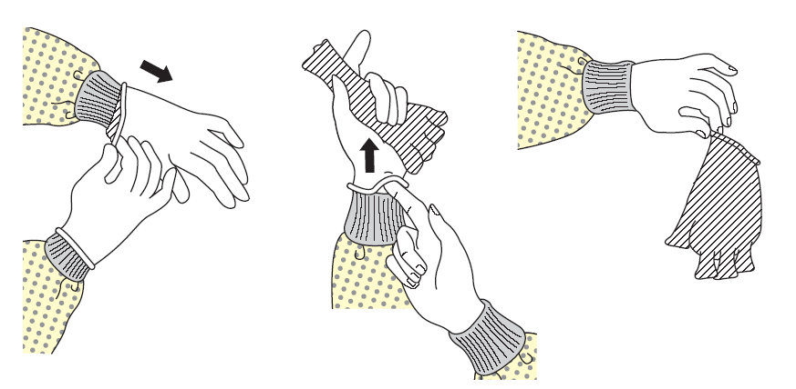
- Wash your hands immediately.

